Test Plan and Baseline Testing Results for the
MEPAS Saturated Zone (Aquifer) Transport Module

1.0 Background and Scope

This paper presents a test plan and the baseline testing results for the Multimedia Environmental Pollutant Assessment System (MEPAS) saturated zone transport module. The purpose of the saturated zone transport module is to simulate the migration and fate of chemical and radionuclide constituents through saturated porous media (i.e., aquifers). The aquifer transport module is specifically designed as an object for inclusion into the Framework for Risk Analysis in Multimedia Environmental Systems (FRAMES), which is a platform that allows for the linking of various multimedia modules into complete transport/exposure assessment systems (Whelan et al., 1997).

The aquifer transport module is being baseline tested for MEPAS version 4.1 and FRAMES version 1.1. The suite of test cases developed for this testing, and presented in this paper, will also be used for assessing the effects of future code modifications. Each time a modification is made to the program code, these test cases are rerun, and their results are compared to the previous run (regression testing). Changes in the results are evaluated to determine if they were expected due to the modification and are an acceptable change, or they are an unintended side effect. In the latter case, the program code can be changed and the testing performed again.

As currently designed, the aquifer module consists of three components: a Module User Interface (MUI), a pre-processor, and the model itself. The MUI (AQU.EXE - version date) obtains the medium physical properties from the user and stores this data in the Global Input Data (GID) file. The pre-processor (PREAQU.EXE - version date) reads the GID file and the Water Flux File (WFF) and prepares a model specific input file (*.WIN). The model (RADCON.EXE - Version 06/18/1999) reads the *.WIN file, performs the simulation, and outputs the results directly to the WFF for contaminant mass flux results, or to the Water Concentration File (WCF) for contaminant aqueous concentration results. The following sections list the requirements of the aquifer transport module, explains how these requirements relate to the specific test cases in this plan, and then presents the test cases themselves.

2.0 Requirements

Requirements for the Aquifer transport module are described in the paper entitled, Requirements for the MEPAS Saturated Zone (Aquifer) Transport Module. These requirements have been reworded into the following list of concise, fundamental requirements suitable for testing.

Requirement  Number | Requirement
1 | Simulate contaminant migration, via advection in one direction, for both chemicals and radionuclides through saturated porous media (i.e., aquifers)
2 | Handle both situations where contaminant enters the aquifer from the vadose zone or from a source within the aquifer
3 | When contaminant enters from a vadose zone, consider the effect that water inflowing from the vadose zone has on contaminant concentrations, especially in proximity to the source
4 | Conserve mass in the simulation
5 | Be able to account for the ingrowth of progeny resulting from degradation/decay, and be able to handle decay chains with up to 9 members (i.e., one parent and eight progeny)
6 | Compute contaminant mass (or activity) fluxes exiting the medium when the medium is not the last transport medium in the scenario
7 | Compute contaminant aqueous concentrations at the medium (downgradient) boundary when the medium is the last transport medium in the scenario
8 | For contaminant flux output, compute the width, height, and depth below the water table of the rectangular plane through which contaminant exits the medium
9 | Output contaminant mass flux or concentration results over a time interval that 1) is sufficient to demonstrate mass conservation, and 2) does not include large intervals where the mass flux or concentration results are zero or near zero
10 | Have no limits on the number of constituents considered in a scenario
11 | Have no limits on the number of flux records read from the input files
12 | Have no limits on the number of flux/concentration records written to the output files
13 | Have no limits on the number of receptors considered in a scenario
14 | Function within the Windows 95 operating system
15 | Meet the module specifications for FRAMES
16 | Create a warning file (*.WRN) at the start of model execution
17 | When a warning condition occurs, write a warning message to the warning file and continue model execution
18 | The MUI shall operate in Windows 95 and have a standard Windows look and feel
19 | The MUI will have on-line help in an HTML format that provides users with an easy-to-understand description of all input parameters
20 | For all input parameters having dimensions associated with them, the MUI will provide users with a choice of units
21 | The MUI will include a reference feature in which the source of the specified value for each input item can be referenced if the user desires
22 | Although the MUI will convert the dimensions of user input data values into the units needed by the model, the MUI will always display the exact value and units in which the user originally entered each input data item
23 | The MUI will show the range of values allowed for each input data item, when the cursor is positioned on that item, as a scrolling message at the bottom of the screen. When an out-of-range value is entered in a field, the MUI will indicate this by a red background in the input field and a scrolling error message in addition to the allowed range message. Data input values within range are shown with a green field background
24 | The MUI will display the module version number, obtained from the module description (DES) file, in an “About” menu
25 | The MUI shall provide estimated Kd’s for each constituent
26 | The MUI shall require only those data necessary to perform the simulation
27 | Provide its results as output to a WFF (for contaminant mass flux results) or WCF (for contaminant aqueous concentration results)
28 | Produce a listing file (*.WLS file) that documents the data actually read in by the model and provides a summary of intermediate calculation results and the simulation results

The following tables show the relationship between these requirements and the test cases described in Section 3. Although some requirements are applicable to all test cases (e.g., function within Windows 95), this table mainly shows which requirements are intended to be tested by each case. There are no test cases for requirements 13 and 14. This is because the module cannot currently read/write an unlimited number of records from/to the input/output files.

Requirement | Test Case Number
Requirement | 01 | 02 | 03 | 04 | 05 | 06 | 07 | 08 | 09 | 10 | 11 | 12 | 13
1 | X |  |  | X | X | X | X | X | X | X | X | X | X
2 | X |  | X |  |  | X
3 | X
4 | X |  |  | X |  |  | X |  |  | X
5 | X
6 | X |  |  | X
7 |  | X |  |  | X | X
8 | X
9 | X
10
11
12
13
14 | X
15 | X
16
17
18 | X
19 | X
20 | X
21 | X
22 | X
23 | X
24 | X
25 | X
26 | X
27 | X | X
28 | X

Requirement | Test Case Number
Requirement | 14 | 15 | 16 | 17 | 18 | 19 | 20 | 21 | 22 | 23
1 | X | X | X | X | X
2
3
4 |  |  |  |  |  |  | X
5 |  |  |  |  |  |  | X
6
7
8
9
10 |  |  |  |  |  |  |  |  | X
11
12 |  |  |  |  |  |  |  |  | X
13 |  |  |  |  |  |  |  |  |  | X
14
15
16 |  |  |  |  |  | X
17 |  |  |  |  |  | X
18
19
20
21
22
23
24
25
26
27
28 |  |  | X | X

3.0 Test Cases and Baseline Testing Results

This section describes the specific test cases used for baseline testing of the MEPAS aquifer transport module. Calculations performed to determine expected results are shown in Appendix A for the appropriate test cases. Appendix B describes the general procedure for conducting a test.

3.1 AQUIFR01

3.1.1 Description and Rationale

This is a simple case to verify the basic functions of the aquifer module. One chemical (no degradation) and one radionuclide will be released to an aquifer from a vadose zone. The aquifer will discharge into a river, so contaminant mass flux will be computed from the aquifer. The source to the aquifer will have dimensions that approximate a point source. The travel distance and aquifer thickness will be such that full vertical mixing is achieved. The source emission for both constituents will be at steady-state for a duration of approximately 10 times the travel time to the river. The distribution coefficients (Kd’s) for both constituents will be set to the values computed by the MUI, the radionuclide will produce no progeny, and the half-life of the radionuclide will be approximately equal to the travel time to the river. The following will be evaluated: 1) user-friendliness of the MUI, 2) on-line help in the MUI, 3) data requested by the MUI, 4) data transfer from the MUI to the GID file, from the GID file to the WIN file, and from the WIN file to the model, 5) mass (or activity) conservation, 6) calculation of the pore-water velocity from the darcy velocity, 7) calculation of the longitudinal (x), lateral (y), and vertical (z) dispersion coefficients, 8) calculation of Kd’s by the MUI, 9) calculation of retardation factors, 10) calculation of decay constants, 11) calculation of the thickness of the source such that the water flowing through the source equals the water flowing in from the vadose zone, 12) computation of contaminant mass (or activity) flux exiting the medium, and 13) the appropriateness of the time interval over which the results are output.

3.1.2 Input Data

The constituent-specific input data for this case is as follows:

Constituents | Acetone | Tritium (as tritiated water)
Inventory | 13,000 g | 1.3 Ci
Emission Rate | 100 g/yr | 0.01 Ci/yr
Emission Duration | 130 yrs | 130 yrs
Half-life | n/a | 12.3 yrs

The source dimensions and medium physical properties are as follows:

Source Length | 0.5 m
Source Width | 1.5 m
Water Flux from Vadose Zone | 70,000 cm³/yr
Soil Type | loamy sand
Sand Content (Wt. basis) | 87 %
Silt Content (Wt. basis) | 11 %
Clay Content (Wt. basis) | 2 %
Organic Matter Content | 0 %
Iron and Aluminum Content | 0 %
pH | 7.64
Darcy Groundwater Velocity | 0.18 m/day
Aquifer Thickness | 3.14 m
Total Porosity | 36.0 %
Effective Porosity | 11.0 %
Dry Bulk Density | 1.76 g/cm³
x-Direction Distance to River | 7350 m
Longitudinal (x) Dispersivity | 735 m
Lateral (y) Dispersivity | 243 m
Vertical (z) Dispersivity | 1.84 m
Percentage of Mass Flux Entering Aquifer | 100 %

3.1.3 Expected Results

It is expected that the MUI will be easy to use, have a functionality consistent with standard Windows 95 software, and that the on-line help will be clear and correct. It is expected that the reference feature will function properly, a choice of units will be provided for the appropriate input parameters, the range of input values for a data item will scroll across the screen bottom, and green/red background feature will function properly. It is expected that the MUI will request only the following information: soil class, sand content, silt content, clay content, organic matter content, iron and aluminum content, pH, aquifer thickness, Darcy flow velocity, total porosity, effective porosity, dry bulk density, x-distance to river, longitudinal (x) dispersivity, lateral (y) dispersivity, vertical (z) dispersivity, percentage of mass flux entering the aquifer, and Kd’s for both acetone and tritium. It is expected that the MUI will estimate a Kd of 5.08 x 10⁻⁴ mL/g for acetone, and 0.0 mL/g for tritium (calculations are documented in Appendix A). It is expected that the transfer of data from the MUI to the GID file, to the WIN file, and then to the model will occur properly and that any necessary unit conversions will be done correctly. Further, the transfer of information from the WFF through the pre-processor to the WIN file, and then to the model will also occur without error and that any necessary unit conversions will be done correctly. The transfer of data between files can be confirmed by visual inspection of these files and the AQUIFR01.WLS file. It is also expected that at the start of model execution, a warning file (MEPAS_AQ.WRN) will be created and remain in the workspace (as AQUIFR01.WRN) after model execution has terminated whether any warning messages occur or not. An error file will also be created at the start of model execution and deleted after model completion if no errors occur. To test for the creation of this file (MEPAS_AQ.ERR), terminate model execution early using “ctrl-c” from the keyboard.

It is expected that the model will compute the following: a pore-water velocity of 5.98 x 10⁴ cm/yr, a longitudinal dispersion coefficient of 4.39 x 10⁹ cm²/yr, a lateral dispersion coefficient of 1.45 x 10⁹ cm²/yr, a vertical dispersion coefficient of 1.10 x 10⁷ cm²/yr, a retardation factor for acetone of 1.01, a retardation factor for tritium of 1.00, a decay constant for tritium of 5.64 x 10⁻² yr⁻¹ (all can be verified by visual inspection of the AQUIFR01.WLS file). It is expected that the preprocessor will compute a thickness for the volume source in the aquifer beneath the vadose zone source of 7.10 x 10⁻² cm (can be verified by visual inspection of the AQUIFR01.WLS file or MEPAS_AQ.WIN file). All of the following results can be confirmed by inspecting the WFF. It is expected that the contaminant mass (or activity) exiting the medium for acetone will achieve steady-state (after year 13), at a value of 100 g/yr. It is expected that the activity of tritium exiting the medium will achieve steady-state (after year 13) at a value slightly less than 5.00 x 10⁹ pCi/yr. This value was arrived at by decaying the flux of tritium from the source for a duration equal to the advective travel time to the river. The actual steady-state result should be slightly less due to longitudinal dispersion. The width of the rectangular plane along the river through which contaminant exits the medium will be 5.90 x 10⁵ cm, and the thickness will be the same as the aquifer thickness (i.e., the upper edge will have a z-coordinate of 0.0 cm and the lower edge will have a z-coordinate of 314 cm). It is expected that the total mass of acetone exiting the medium will be equal to its starting inventory (13,000 g), and that the activity of tritium exiting the medium will be slightly less than half its starting inventory (0.65 Ci). The mass (or activity) values will be written to the AQUIFR01.WLS file, but should also by computed from data in the WFF (for verification). Further, it is expected that the time interval over which the results are output will properly define the contaminant mass (or activity) flux without having a large interval over which the results are zero or near zero.

3.1.4 Baseline Testing Results

When setting up this case, the ease-of-use and functionality of the aquifer module MUI was evaluated. The on-line help for the MUI was reviewed and revised to be more clear and correct. Further, the reference feature, choice of units for the appropriate input parameters, the range of input values for a data item, and the green/red background feature all functioned properly. The MUI requested only the information necessary to perform the simulation (i.e., all required parameters were asked for with no extra parameters being required). The Kd estimations made by the MUI matched the expected results exactly.

The transfer of information from the MUI to the GID file, from the GID file to the model input file, and then from the input file to the model itself was evaluated. All information was transferred correctly and the necessary unit conversions occurred without error. The transfer of information from the input WFF to the model input file and then the model itself was also evaluated, and was found to be correct. At the start of model execution, a warning file was created, which remained in the workspace after execution was completed (this file contained no actual warning messages). The creation of the error file was checked by issuing “ctrl-c” during model execution. The error file is being created correctly, and is being deleted after the model runs to completion.

The model computed the following: a pore-water velocity of 164 cm/day (5.99 x 10⁴ cm/yr), a longitudinal dispersion coefficient of 4.39 x 10⁹ cm²/yr, a lateral dispersion coefficient of 1.45 x 10⁹ cm²/yr, a vertical dispersion coefficient of 1.10 x 10⁷ cm²/yr, a retardation factor for acetone of 1.01, a retardation factor for tritium of 1.00, a decay constant for tritium of 5.64 x 10⁻² yr⁻¹, a thickness for the volume source in the aquifer beneath the vadose zone source of 7.10 x 10⁻² cm, a width for the rectangular area through which the plume exits the medium of 5.90 x 10⁵ cm, an upper coordinate for this rectangular area of 0.0 cm, and a lower coordinate of 314 cm. These values either exactly match or are very close to the expected results. The very slight differences that occur are due to small rounding errors caused by unit conversions.

The mass flux of acetone exiting the medium achieved a steady-state value of 100 g/yr from 51.6 to 129.9 years. The activity flux of tritium exiting the medium achieved a steady-state value of 4.92 x 10⁹ pCi/yr from 49.2 to 129.2 years. The acetone result matches its expected result exactly, and the tritium result is slightly less than 5.00 x 10⁹ pCi/yr, as expected. The total mass of acetone exiting the medium was 13,002 g, and the total activity of tritium exiting the medium was 0.639 Ci. Both of these results match the expected results very well, so mass was conserved during the simulation. The time interval over which the output results were reported provided good resolution without any large time periods over which the result was zero or very near zero.

3.2 AQUIFR02

3.2.1 Description and Rationale

This case is exactly the same as AQUIFR01, except that contaminant aqueous concentrations are computed as an endpoint, rather than contaminant mass (or activity) flux exiting the medium. This is the first of several checks of the numerical solution used to compute concentrations from a volume source. Because the source for this case approximates a point source, the numerically computed steady-state concentration at the receptor will be compared to an analytical solution for a point-source release at the water table (or a line source in the z-direction) where full vertical mixing is achieved at the receptor.

3.2.2 Input Data

The input data for this case is the same as for AQUIFR01 (see Section 3.1.2).

3.2.3 Expected Results

The analytical equation for a steady-state, centerline concentration for a point source (or a line source in the z-direction) under full vertical mixing can be used. The expected steady-state concentrations for acetone and tritium are 9.99 x 10⁻¹¹ g/mL and 4.92 x 10⁻³ pCi/mL, respectively (calculations are documented in Appendix A).

3.2.4 Baseline Testing Results

The concentration of acetone achieved steady-state at a value of 9.99 x 10⁻¹¹ g/mL for years 51.1 to 128.6, and the concentration of tritium achieved steady-state at a value of 4.92 x 10⁻³ pCi/mL for years 42.0 to 128.4. These results match the expected results exactly.

3.3 AQUIFR03

3.3.1 Description and Rationale

This case is similar to AQUIFR02, except that the source of contaminant is an existing groundwater plume (i.e., y-z area source). This is the first of several checks of the numerical solution used to compute concentrations from a y-z area source. Because the source for this case approximates a point source, the numerically computed steady-state concentration at the receptor will be compared to an analytical solution for a point-source release at the water table (or a line source in the z-direction) where full vertical mixing is achieved at the receptor.

3.3.2 Input Data

The input data for this case is identical to that for AQUIFR01 (see Section 3.1.2), except that the source depth in the aquifer is 1.07 x 10⁻² cm. The source width remains unchanged and the source length is not an input parameter. These dimensions are identical to the dimensions of a vertical cross-section of the volume source of AQUIFR01 and AQUIFR02.

3.3.3 Expected Results

The expected results are identical to AQUIFR02 (see Section 3.2.3).

3.3.4 Baseline Testing Results

The concentration of acetone achieved steady-state at a value of 9.99 x 10⁻¹¹ g/mL for years 51.1 to 128.6, and the concentration of tritium achieved steady-state at a value of 4.92 x 10⁻³ pCi/mL for years 45.4 to 128.1. These results match the expected results exactly.

3.4 AQUIFR04

3.4.1 Description and Rationale

This case adds further complexity to AQUIFR01/02/03. Again, a point source will be simulated and receptor concentrations will achieve steady state, but full vertical mixing will not be achieved. The travel distance in the aquifer will be longer than the distance at which half-vertical mixing is achieved, but shorter than the distance at which full mixing is achieved. The steady-state flux at the river boundary and the dimensions of the rectangular plane through which contaminant exits the medium will be evaluated. Mass (or activity) conservation will also be evaluated.

3.4.2 Input Data

The constituent-specific input data for this case is as follows:

Constituents | Acetone | Tritium (as tritiated water)
Inventory | 13,000 g | 1.3 Ci
Emission Rate | 100 g/yr | 0.01 Ci/yr
Emission Duration | 130 yrs | 130 yrs
Half-life | n/a | 12.4 yrs

Kd’s computed by the MUI will be used (should be 5.08 x 10⁻⁴ mL/g for benzene and 0.0 mL/g for tritium). The source dimensions and medium physical properties are as follows:

Source Length | 1.0 m
Source Width | 1.0 m
Water Flux from Vadose Zone | 70,000 cm³/yr
Soil Type | loamy sand
Sand Content (Wt. basis) | 87 %
Silt Content (Wt. basis) | 11 %
Clay Content (Wt. basis) | 2 %
Organic Matter Content | 0 %
Iron and Aluminum Content | 0 %
pH | 7.64
Darcy Groundwater Velocity | 0.018 m/day
Aquifer Thickness | 10.0 m
Total Porosity | 0.360 (fraction)
Effective Porosity | 0.110 (fraction)
Dry Bulk Density | 1.76 g/cm³
x-Direction Distance to River | 350 m
Longitudinal (x) Dispersivity | 0.0 m
Lateral (y) Dispersivity | 11.6 m
Vertical (z) Dispersivity | 0.087 m
Percentage of Mass Flux Entering Aquifer | 100 %

3.4.3 Expected Results

It is expected that the width of the rectangular plane along the river through which contaminant exits the medium will be 2.75 x 10⁴ cm, and the thickness will be 9.76 x 10² cm (with the z-coordinate for the upper edge at 0.0 cm). The steady-state flux of acetone exiting the medium will be the same as the source flux (100 g/yr), and the steady-state flux of tritium is expected to be 7.21 x 10⁹ pCi/yr (calculations are documented in Appendix A). The actual result for tritium may be slightly less than the expected result due to a small amount of longitudinal dispersion (molecular diffusion added automatically by the model) and its effect on decay. The mass of acetone exiting the medium is expected to be the same as the starting inventory (13,000 g) and the activity of tritium exiting the medium is expected to be slightly less than 0.94 Ci.

3.4.4 Baseline Testing Results

The flux of acetone and tritium exiting the medium achieved the steady-state values of 100 g/yr for 9.3 to 135.0 years, and 7.19 x 10⁹ pCi/yr for 9.2 to 134.9 years, respectively. The width of the plane through which contaminant exits the medium was 2.75 x 10⁴ cm and the height of the plane is 9.76 x 10² cm, with the upper z-coordinate being zero. These results either match the expected results exactly. The mass of acetone exiting the medium was 12,914 g, and the activity of tritium exiting the medium was 0.928 Ci. These values are a good match to the expected results (there is some uncertianty in these computed values, because linear interpolation was used between time steps and this is not necessarily appropriate because of the very steep rising and falling limbs of the time series concentration output caused by turning off longitudinal dispersion).

3.5 AQUIFR05

3.5.1 Description and Rationale

This case is the same as AQUIFR04, except that concentrations in the aquifer will be computed. Because the source for this case approximates a point source, the numerically computed steady-state concentration at the receptor will be compared to an analytical solution for a point source under non-fully mixed conditions developed assuming longitudinal dispersion to be unimportant.

3.5.2 Input Data

The input data is the same as for AQUIFR04 (see Section 3.4.2).

3.5.3 Expected Results

The expected steady-state concentrations for acetone and tritium are 7.39 x 10⁻⁹ g/mL and 5.33 x 10⁻¹ pCi/mL, respectively (calculations are documented in Appendix A). The actual result for tritium may be slightly less than the expected result due to a small amount of longitudinal dispersion (molecular diffusion added automatically by the model) and its effect on decay.

3.5.4 Baseline Testing Results

The concentrations of acetone and tritium achieved steady-state at values of 7.39 x 10⁻⁹ g/mL for years 9.1 to 132.7 and 5.32 x 10⁻¹ pCi/mL also for years 9.1 to 132.7. These results match the expected results very well.

3.6 AQUIFR06

3.6.1 Description and Rationale

This case is similar to AQUIFR05, except that the source of contaminant is an existing groundwater plume (i.e., y-z area source).

3.6.2 Input Data

The input data for this case is identical to that for AQUIFR04 (see Section 3.4.2), except that the source depth in the aquifer is 1.07 cm. The source width remains unchanged and the source length is not an input parameter. These dimensions are identical to the dimensions of a vertical cross-section of the volume source of AQUIFR05.

3.6.3 Expected Results

The expected results are identical to AQUIFR05 (see Section 3.5.3).

3.6.4 Baseline Testing Results

The concentrations of acetone and tritium achieved steady-state at values of 7.39 x 10⁻⁹ g/mL for years 9.1 to 132.7 and 5.32 x 10⁻¹ pCi/mL for years 9.2 to 134.9. These results match the expected results very well.

3.7 AQUIFR07

3.7.1 Description and Rationale

In this case, a horizontal line source (in the y-direction) at the water-table will be approximated and receptor concentrations will achieve steady state, but full vertical mixing will not be achieved. The travel distance in the aquifer will be shorter than the distance at which half-vertical mixing is achieved. The steady-state flux at the river boundary and the dimensions of the rectangular plane through which contaminant exits the medium will be evaluated. Mass (or activity) conservation will also be evaluated.

3.7.2 Input Data

The constituent-specific input data for this case is as follows:

Constituents | Acetone | Tritium (as tritiated water)
Inventory | 1,300,000 g | 130 Ci
Emission Rate | 10,000 g/yr | 1.0 Ci/yr
Emission Duration | 130 yrs | 130 yrs
Half-life | n/a | 12.4 yrs

Kd’s computed by the MUI will be used (should be 5.08 x 10⁻⁴ mL/g for acetone and 0.0 mL/g for tritium). The source dimensions and medium physical properties are as follows:

Source Length | 1.0 m
Source Width | 100.0 m
Water Flux from Vadose Zone | 7,000,000 cm³/yr
Soil Type | loamy sand
Sand Content (Wt. basis) | 87 %
Silt Content (Wt. basis) | 11 %
Clay Content (Wt. basis) | 2 %
Organic Matter Content | 0 %
Iron and Aluminum Content | 0 %
pH | 7.64
Darcy Groundwater Velocity | 0.018 m/day
Aquifer Thickness | 40.0 m
Total Porosity | 0.360 (fraction)
Effective Porosity | 0.110 (fraction)
Dry Bulk Density | 1.76 g/cm³
x-Direction Distance to Receptor | 500 m
Longitudinal (x) Dispersivity | 0.0 m
Lateral (y) Dispersivity | 16.5 m
Vertical (z) Dispersivity | 0.125 m
Percentage of Mass Flux Entering Aquifer | 100 %

3.7.3 Expected Results

It is expected that the width of the rectangular plane along the river through which contaminant exits the medium will be 3.88 x 10⁴ cm, and the thickness will be 1.70 x 10³ cm (with the z-coordinate for the upper edge at 0.0 cm). The steady-state flux of acetone exiting the medium will be the same as the source flux (10,000 g/yr), and the steady-state flux of tritium is expected to be 6.27 x 10¹¹ pCi/yr (calculations are documented in Appendix A). The actual result for tritium may be slightly less than the expected result due to a small amount of longitudinal dispersion (molecular diffusion added automatically by the model) and its effect on decay. The mass of acetone exiting the medium is expected to be the same as the starting inventory (1,300,000 g) and the activity of tritium exiting the medium is expected to be 81.4 Ci., and may be slightly less.

3.7.4 Baseline Testing Results

The flux of acetone and tritium exiting the medium achieved the steady-state values of 10,000 g/yr for 11.0 to 136.4 years, and 6.24 x 10¹² pCi/yr for 10.8 to 136.0 years, respectively. The width of the plane through which contaminant exits the medium was 3.95 x 10⁴ cm and the height of the plane is 1.71 x 10³ cm, with the upper z-coordinate being zero. These results agree well with the expected results. The mass of acetone exiting the medium was 1,288,630 g, and the activity of tritium exiting the medium was 0.802 Ci. These values are a good match to the expected results (there is some uncertianty in these computed values, because linear interpolation was used between time steps and this is not necessarily appropriate because of the very steep rising and falling limbs of the time series concentration output caused by turning off longitudinal dispersion).

3.8 AQUIFR08

3.8.1 Description and Rationale

This case is the same as AQUIFR07, except that concentrations in the aquifer will be computed. Because the source for this case approximates a horizontal (y-direction) line source, the numerically computed steady-state concentration at the receptor will be compared to an analytical solution for a horizontal (y-direction) line source under non-fully mixed conditions developed assuming longitudinal dispersion to be unimportant.

3.8.2 Input Data

The input data is the same as for AQUIFR07 (see Section 3.7.2).

3.8.3 Expected Results

The expected steady-state concentrations for acetone and tritium are 3.28 x 10⁻⁰⁷ g/mL and 20.6 pCi/mL, respectively (calculations are documented in Appendix A). The actual result for tritium may be slightly less than the expected result due to a small amount of longitudinal dispersion (molecular diffusion added automatically by the model) and its effect on decay.

3.8.4 Baseline Testing Results

The concentrations of acetone and tritium achieved steady-state at values of 3.28 x 10⁻⁷ g/mL for years 10.8 to 136.5 and 20.5 pCi/mL for years 11.6 to 135.2. These results match the expected results very well.

3.9 AQUIFR09

3.9.1 Description and Rationale

This case is similar to AQUIFR08, except that the source of contaminant is an existing groundwater plume (i.e., y-z area source).

3.9.2 Input Data

The input data for this case is identical to that for AQUIFR07 (see Section 3.7.2), except that the source depth in the aquifer is 1.07 cm. The source width remains unchanged and the source length is not an input parameter. These dimensions are identical to the dimensions of a vertical cross-section of the volume source of AQUIFR08

3.9.3 Expected Results

The expected results are identical to AQUIFR08 (see Section 3.8.3).

3.9.4 Baseline Testing Results

The concentrations of acetone and tritium achieved steady-state at values of 3.28 x 10⁻⁷ g/mL for years 11.6 to 135.2 and 20.5 pCi/mL also for years 11.6 to 135.2. These results match the expected results very well.

3.10 AQUIFR10

3.10.1 Description and Rationale

In this case, a vertical (z-direction) line source at the water-table will be approximated and receptor concentrations will achieve steady state, but full vertical mixing will not be achieved. The steady-state flux at the river boundary and the dimensions of the rectangular plane through which contaminant exits the medium will be evaluated. Mass (or activity) conservation will also be evaluated.

3.10.2 Input Data

The constituent-specific input data for this case is as follows:

Constituents | Acetone | Tritium (as tritiated water)
Inventory | 130,000 g | 13 Ci
Emission Rate | 1000 g/yr | 0.1 Ci/yr
Emission Duration | 130 yrs | 130 yrs
Half-life | n/a | 12.4 yrs

Kd’s computed by the MUI will be used (should be 5.08 x 10⁻⁴ mL/g for acetone and 0.0 mL/g for tritium). The source dimensions and medium physical properties are as follows:

Source Length | 1.0 cm
Source Width | 1.0 m
Water Flux from Vadose Zone | 65,800,000 cm³/yr
Soil Type | loamy sand
Sand Content (Wt. basis) | 87 %
Silt Content (Wt. basis) | 11 %
Clay Content (Wt. basis) | 2 %
Organic Matter Content | 0 %
Iron and Aluminum Content | 0 %
pH | 7.64
Darcy Groundwater Velocity | 0.018 m/day
Aquifer Thickness | 40.0 m
Total Porosity | 0.360 (fraction)
Effective Porosity | 0.110 (fraction)
Dry Bulk Density | 1.76 g/cm³
x-Direction Distance to Receptor | 500 m
Longitudinal (x) Dispersivity | 0.0 m
Lateral (y) Dispersivity | 16.5 m
Vertical (z) Dispersivity | 0.125 m
Percentage of Mass Flux Entering Aquifer | 100 %

3.10.3 Expected Results

It is expected that the width of the rectangular plane along the river through which contaminant exits the medium will be 3.95 x 10⁴ cm, and the thickness will be 2.21 x 10³ cm (with the z-coordinate for the upper edge at 0.0 cm). The steady-state flux of acetone exiting the medium will be the same as the source flux (1000 g/yr), and the steady-state flux of tritium is expected to be 6.27 x 10¹⁰ pCi/yr (calculations are documented in Appendix A). The actual result for tritium may be slightly less than the expected result due to a small amount of longitudinal dispersion (molecular diffusion added automatically by the model) and its effect on decay. The mass of acetone exiting the medium is expected to be the same as the starting inventory (130,000 g) and the activity of tritium exiting the medium is expected to be 8.14 Ci, or slightly less.

3.10.4 Baseline Testing Results

The flux of acetone and tritium exiting the medium achieved the steady-state values of 1000 g/yr for 11.6 to 135.2 years, and 6.24 x 10¹¹ pCi/yr for 11.8 to 136.3 years, respectively. The width of the plane through which contaminant exits the medium was 3.95 x 10⁴ cm and the height of the plane is 2.21 x 10³ cm, with the upper z-coordinate being zero. These results agree well with the expected results. The mass of acetone exiting the medium was 126,848 g, and the activity of tritium exiting the medium was 7.99 Ci. These values are a good match to the expected results (there is some uncertianty in these computed values, because linear interpolation was used between time steps and this is not necessarily appropriate because of the very steep rising and falling limbs of the time series concentration output caused by turning off longitudinal dispersion).

3.11 AQUIFR11

3.11.1 Description and Rationale

This case is the same as AQUIFR10, except that concentrations in the aquifer will be computed. Because the source for this case approximates a vertical (z-direction) line source, the computed steady-state concentrations at the receptor will be compared to an analytical solution for a vertical (z-direction) line source under non-fully mixed conditions developed assuming longitudinal dispersion to be unimportant.

3.11.2 Input Data

The input data is the same as for AQUIFR010 (see Section 3.10.2).

3.11.3 Expected Results

The expected steady-state concentrations for benzene and tritium are 2.97 x 10⁻⁰⁸ g/mL and 1.86 pCi/mL, respectively (calculations are documented in Appendix A). The actual result for tritium may be slightly less than the expected result due to a small amount of longitudinal dispersion (molecular diffusion added automatically by the model) and its effect on decay.

3.11.4 Baseline Testing Results

The concentrations of acetone and tritium achieved steady-state at values of 2.97 x 10⁻⁸ g/mL for years 11.8 to 136.5 and 1.85 pCi/mL for years 11.6 to 135.2. These results match the expected results very well.

3.12 AQUIFR12

3.12.1 Description and Rationale

This case is similar to AQUIFR11, except that the source of contaminant is an existing groundwater plume (i.e., y-z area source).

3.12.2 Input Data

The input data for this case is identical to that for AQUIFR10 (see Section 3.10.2), except that the source depth in the aquifer is 10.0 m. The source width remains unchanged and the source length is not an input parameter. These dimensions are identical to the dimensions of a cross-section of the volume source of AQUIFR11.

3.12.3 Expected Results

The expected results are identical to AQUIFR11 (see Section 3.11.3).

3.12.4 Baseline Testing Results

The concentrations of acetone and tritium achieved steady-state at values of 2.97 x 10⁻⁸ g/mL for years 11.6 to 135.2 and 1.85 pCi/mL also for years 11.6 to 135.2. These results match the expected results very well.

3.13 AQUIFR13

3.13.1 Description and Rationale

In this case, a y-z area source having an upper coordinate at the water-table will be approximated using a volume source, and receptor concentrations will achieve steady state, but full vertical mixing will not be achieved. The numerically computed steady-state concentrations will be compared to an analytical solution for a y-z area source developed assuming longitudinal dispersion to be unimportant.

3.13.2 Input Data

The constituent-specific input data for this case is as follows:

Constituents | Benzene | Tritium (as tritiated water)
Inventory | 1.2 x 10⁹ g | 120,000 Ci
Emission Rate | 2.0 x 10⁷ g/yr | 2,000 Ci/yr
Emission Duration | 60 yrs | 60 yrs
Half-life | n/a | 12.4 yrs

Kd’s computed by the MUI will be used (should be 0.4094 mL/g for benzene and 0.0 mL/g for tritium). The source dimensions and medium physical properties are as follows:

Source Length | 1.0 m
Source Width | 100 m
Water Flux from Vadose Zone | 1.096 x 10¹¹ cm³/yr
Soil Type | silt loam
Sand Content (Wt. basis) | 25 %
Silt Content (Wt. basis) | 63 %
Clay Content (Wt. basis) | 12 %
Organic Matter Content | 0 %
Iron and Aluminum Content | 0 %
pH | 7
Darcy Groundwater Velocity | 0.03 m/day
Aquifer Thickness | 365.0 m
Total Porosity | 0.463 (fraction)
Effective Porosity | 0.180 (fraction)
Dry Bulk Density | 1.42 g/cm³
x-Direction Distance to Receptor | 400 m
Longitudinal (x) Dispersivity | 0.0 m
Lateral (y) Dispersivity | 13.2 m
Vertical (z) Dispersivity | 0.1 m
Percentage of Mass Flux Entering Aquifer | 100 %

3.13.3 Expected Results

The expected steady-state concentrations for benzene and tritium are 6.81 x 10⁻⁰⁵ g/mL and 4.72 x 10³ pCi/mL, respectively (calculations are documented in Appendix A). The actual result for tritium may be slightly less than the expected result due to a small amount of longitudinal dispersion (molecular diffusion added automatically by the model) and its effect on decay.

3.13.4 Baseline Testing Results

The concentrations of benzene and tritium achieved steady-state at values of 6.82 x 10⁻⁸ g/mL for years 29.8 to 87.0 and 4.71 x 10³ pCi/mL for years 8.2 to 66.5. These results match the expected results very well.

3.14 AQUIFR14

3.14.1 Description and Rationale

This case is similar to AQUIFR13, except that the source of contaminant is an existing groundwater plume (i.e., y-z area source).

3.14.2 Input Data

The input data for this case is identical to that for AQUIFR13 (see Section 3.13.2), except that the source depth in the aquifer is 100.0 m. The source width remains unchanged and the source length is not an input parameter. These dimensions are identical to the dimensions of a cross-section of the volume source of AQUIFR13.

3.14.3 Expected Results

The expected results are identical to AQUIFR13 (see Section 3.13.3).

3.14.4 Baseline Testing Results

The concentrations of benzene and tritium achieved steady-state at values of 6.82 x 10⁻⁸ g/mL for years 29.1 to 86.5 and 4.71 x 10³ pCi/mL for years 8.0 to 65.1. These results match the expected results very well.

3.15 AQUIFR15

3.15.1 Description and Rationale

In this case, a point source at the water-table will be approximated using a volume source. This case will be temporally far-field, so the analytical solution for an instantaneous release will be used by the code. Because this case is also spatially far-field, this solution will be compared to an analytical solution for an instantaneous release from a point source.

3.15.2 Input Data

The constituent-specific input data for this case is as follows:

Constituents | Benzene | Tritium (as tritiated water)
Inventory | 2.5 x 10⁷ g | 3.0 Ci
Emission Rate | 2.5 x 10⁷ g/yr | 3.0 Ci/yr
Emission Duration | 1 yrs | 1 yrs
Half-life | n/a | 12.4 yrs

Kd’s computed by the MUI will be used (should be 0.3837 mL/g for benzene and 0.0 mL/g for tritium). The source dimensions and medium physical properties are as follows:

Source Length | 1.0 cm
Source Width | 1.0 cm
Water Flux from Vadose Zone | 1.06 x 10³ cm³/yr
Soil Type | loam
Sand Content (Wt. basis) | 45 %
Silt Content (Wt. basis) | 40 %
Clay Content (Wt. basis) | 15 %
Organic Matter Content | 0 %
Iron and Aluminum Content | 0 %
pH | 7
Darcy Groundwater Velocity | 2.90 x 10⁻² m/day
Aquifer Thickness | 100.0 m
Total Porosity | 0.250 (fraction)
Effective Porosity | 0.100 (fraction)
Dry Bulk Density | 1.42 g/cm³
x-Direction Distance to Receptor | 5000 m
Longitudinal (x) Dispersivity | 500 m
Lateral (y) Dispersivity | 165 m
Vertical (z) Dispersivity | 1.25 m
Percentage of Mass Flux Entering Aquifer | 100 %

3.15.3 Expected Results

The time-varying concentration of benzene and tritium at the receptor location were computed using equations in Whelan et al. (1996) and are plotted in the next section along with the actual testing results. The peak concentrations are expected to be 2.40 x 10⁻⁸ g/mL at year 245 and 3.03 x 10⁻³ pCi/mL at year 28 for benzene and tritium, respectively.

3.15.4 Baseline Testing Results

The peak concentrations were 2.38 x 10⁻⁸ g/mL at year 257.0 for benzene, and 3.06 x 10⁻³ pCi/mL at year 27.9 for tritium. These results match the expected results very well. The slight differences in concentrations were traced to numerical imprecision in the subtraction of error functions for both the x- and y-direction line source solutions. The plots that follow show the full time-varying output results with the expected results.

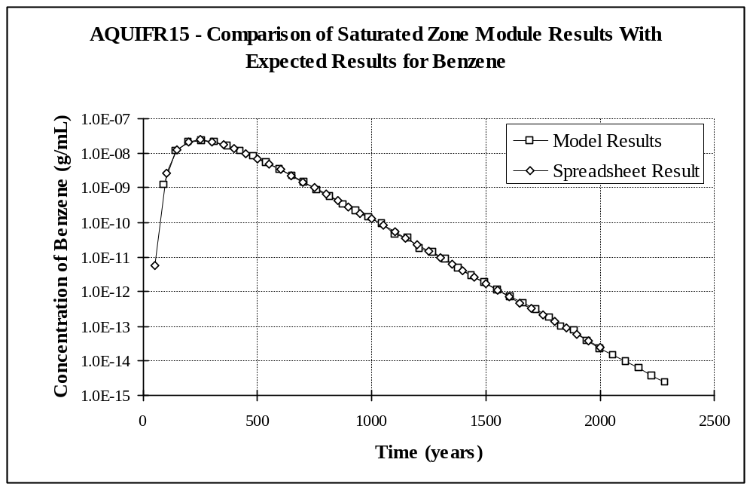
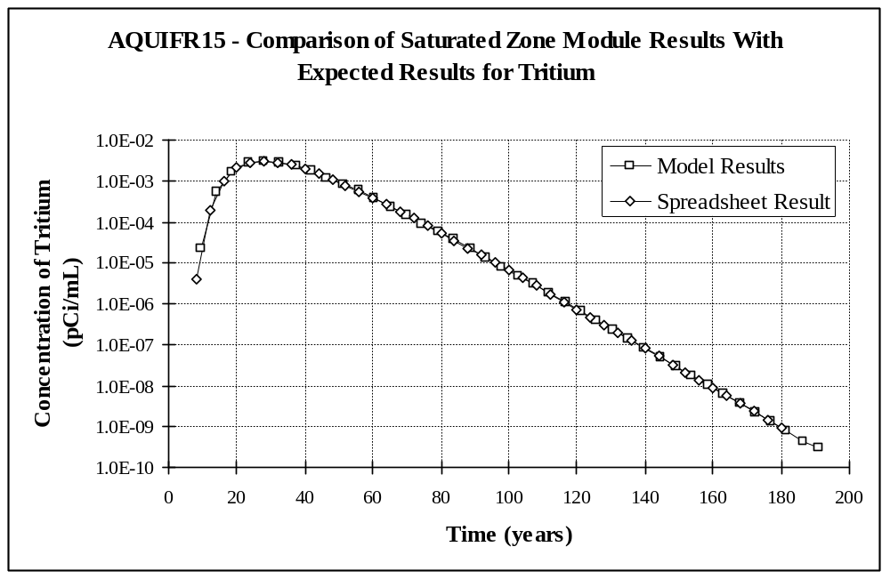

3.16 AQUIFR16

3.16.1 Description and Rationale

This case is similar to AQUIFR15, except that the source of contaminant is an existing groundwater plume (i.e., y-z area source).

3.16.2 Input Data

The input data for this case is identical to that for AQUIFR15 (see Section 3.15.2), except that the source depth in the aquifer is 1.0 m. The source width remains unchanged and the source length is not an input parameter. These dimensions are identical to the dimensions of a cross-section of the volume source of AQUIFR15.

3.16.3 Expected Results

The expected results are identical to AQUIFR15 (see Section 3.15.3).

3.16.4 Baseline Testing Results

The peak concentrations were 2.40 x 10⁻⁸ g/mL at year 256.5 for benzene, and 3.04 x 10⁻³ pCi/mL at year 28.0 for tritium. These results match the expected results very well. The plots that follow show the full time-varying output results with the expected results.

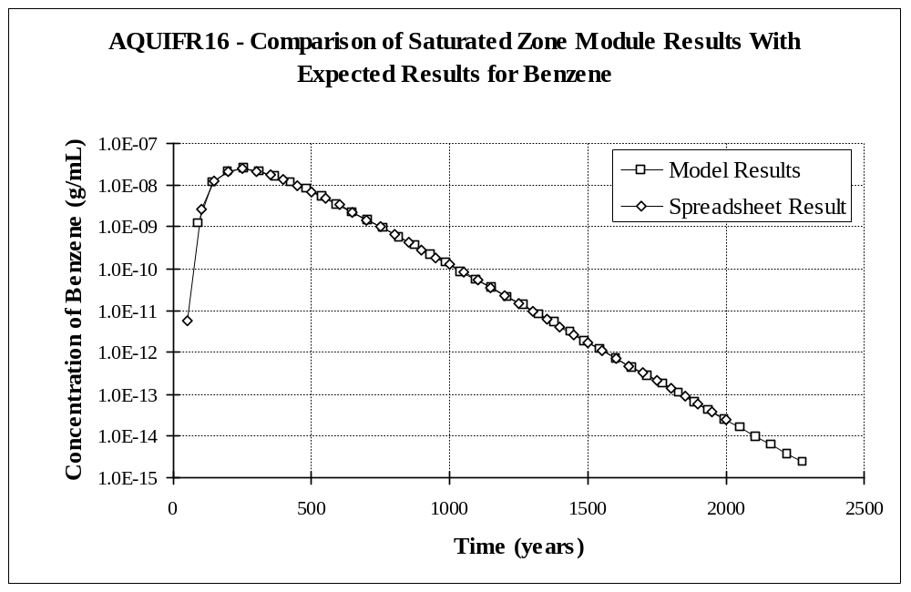
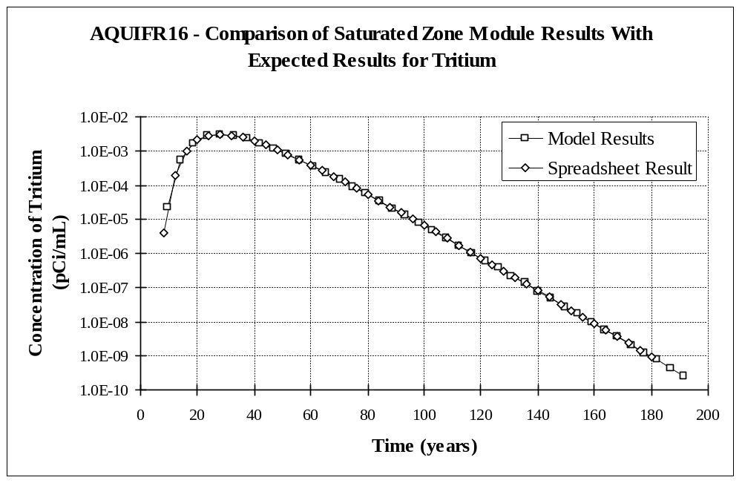

3.17 AQUIFR17

3.17.1 Description and Rationale

This case is identical to AQUIFR15, except that the numerical solution will be invoked instead of the analytical solution for an instantaneous release.

3.17.2 Input Data

The input data for this case is identical to that for AQUIFR15 (see Section 3.15.2).

3.17.3 Procedure

To run this case, it is necessary to make a temporary version of the batch file that runs the saturated zone module and also edit the input file to the model (MEPAS_AQ.WIN). First, make a copy of the batch file (AQU.BAT) and name is something like AQU.SAV. Then, using a text editor, insert the command ‘pause’ (without the quotes) just before the line to runs the model (radcon.exe). Save the batch file, and then run the module. Execution will halt after the pre-processor is run. When this happens, edit the file entitled MEPAS_AQ.WIN to change the variable RRATIO from 30.0 to 1.0E+20 in two places. RRATIO is the third value on lines 9 and 28. This field occupies the columns 21 to 30, and needs to be right justified. Save the WIN file, and then reactivate the window for module execution and hit any key to resume. When module execution is completed, delete AQU.BAT and copy AQU.SAV back to AQU.BAT.

3.17.4 Expected Results

The expected results are identical to AQUIFR15 (see Section 3.15.3).

3.17.5 Baseline Testing Results

The peak concentrations were 2.41 x 10⁻⁸ g/mL at year 257.0 for benzene, and 3.02 x 10⁻³ pCi/mL at year 27.9 for tritium. These results match the expected results very well. The plots that follow show the full time-varying output results with the expected results.

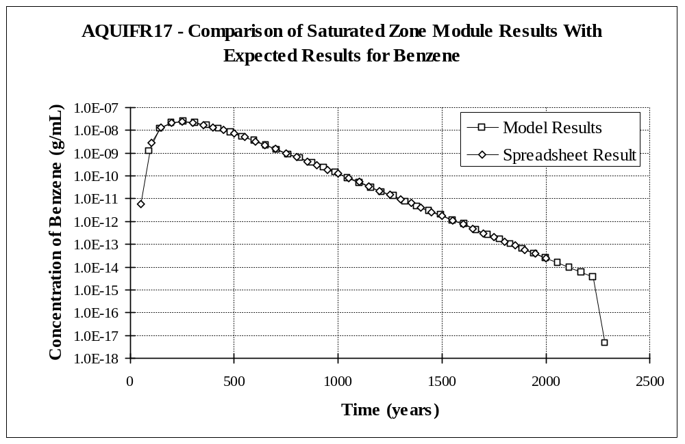
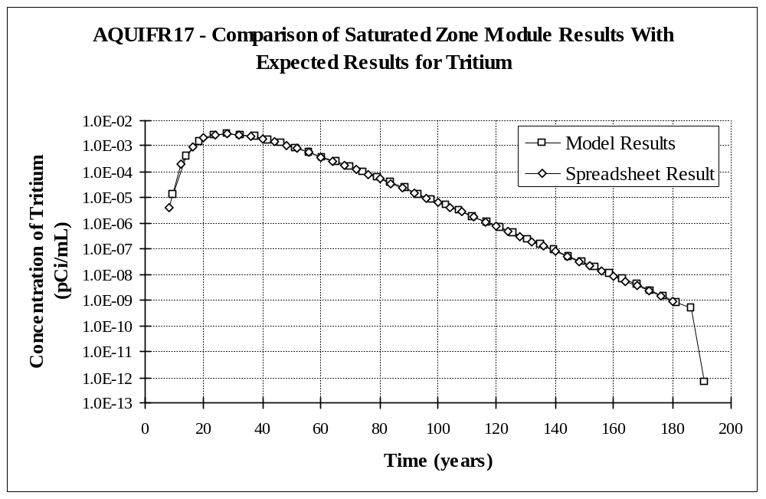

3.18 AQUIFR18

3.18.1 Description and Rationale

This case is identical to AQUIFR16, except that the numerical solution will be invoked instead of the analytical solution for an instantaneous release.

3.18.2 Input Data

The input data for this case is identical to that for AQUIFR16 (see Section 3.16.2).

3.18.3 Procedure

To run this case, follow the same procedure as was used for AQUIFR17 (see Section 3.17.3).

3.18.4 Expected Results

The expected results are identical to AQUIFR15 (see Section 3.15.3).

3.18.5 Baseline Testing Results

The peak concentrations were 2.40 x 10⁻⁸ g/mL at year 256.5 for benzene, and 3.03 x 10⁻³ pCi/mL at year 28.0 for tritium. These results match the expected results very well.

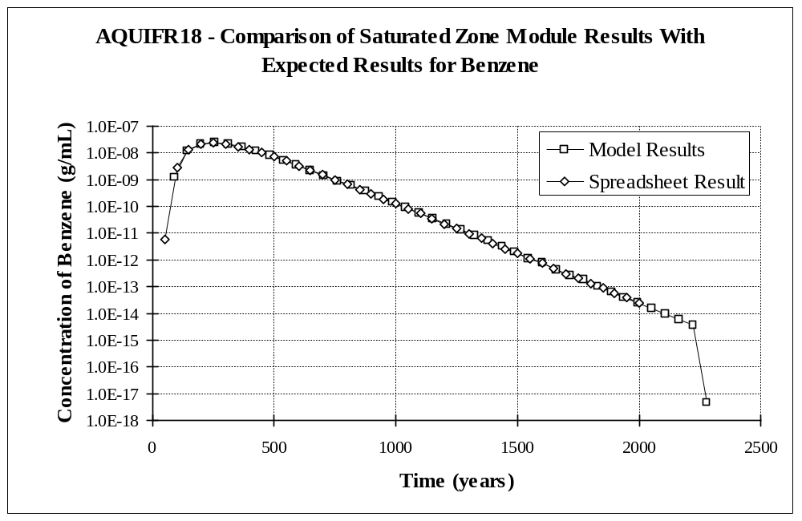

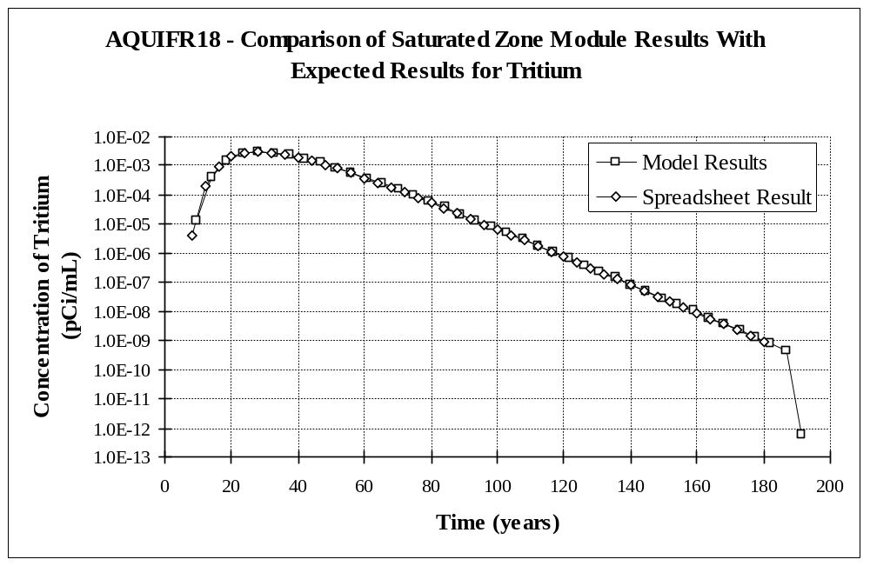

3.19 AQUIFR19

3.19.1 Description and Rationale

This case will test the near-field capability of the aquifer module. In this case, a receptor well will be placed at the downgradient edge of the source at the water table. Concentrations at the receptor should be the same as the concentrations at the source. The benzene concentration will exceed the solubility limit, thus testing the warning message capability.

3.19.2 Input Data

The constituent-specific input data for this case is as follows:

Constituents | Benzene | Tritium (as tritiated water)
Inventory | 5.0 x 10⁶ g | 0.01 Ci
Emission Rate | 5.0 x 10⁵ g/yr | 0.001 Ci/yr
Emission Duration | 10 yrs | 10 yrs
Half-life | n/a | 12.4 yrs

Kd’s computed by the MUI will be used (should be 0.4094 mL/g for benzene and 0.0 mL/g for tritium). The source dimensions and medium physical properties are as follows:

Source Length | 30.0 m
Source Width | 30.0 m
Water Flux from Vadose Zone | 4.50 x 10⁷ cm³/yr
Soil Type | sand
Sand Content (Wt. basis) | 90 %
Silt Content (Wt. basis) | 0 %
Clay Content (Wt. basis) | 0 %
Organic Matter Content | 0 %
Iron and Aluminum Content | 10 %
pH | 7.8
Darcy Groundwater Velocity | 2.0 m/day
Aquifer Thickness | 75.0 m
Total Porosity | 0.200 (fraction)
Effective Porosity | 0.150 (fraction)
Dry Bulk Density | 1.90 g/cm³
x-Direction Distance to Receptor | 15.0 m
Longitudinal (x) Dispersivity | 1.5 m
Lateral (y) Dispersivity | 0.5 m
Vertical (z) Dispersivity | 0.00375 m
Percentage of Mass Flux Entering Aquifer | 100 %

3.19.3 Expected Results

It is expected that concentrations at the receptor will quickly achieve steady-state for a duration of 10 years, and be equal to the concentrations in the vadose zone water: 1.11 x 10⁻² g/mL and 22.2 pCi/mL for benzene and tritium, respectively (computed by taking the contaminant flux divided by the water flux from the vadose zone). It is further expected that a warning message will be written to the *.WRN file stating that the concentration for benzene exceeds its solubility limit.

3.19.4 Baseline Testing Results

Concentrations for benzene and tritium did quickly reach steady-state for a duration of 10 years, but the concentrations were about 2 orders of magnitude below the expected concentrations (6.78 x 10-5 g/mL for benzene and 1.36 x 10-1 pCi/mL for tritium). When the x-, y-, and z-dispersivities were set to -3.9 x 10⁻⁴ cm in the model input file (has the effect of causing the dispersion coefficients to be near zero, thus simulating plug flow), the expected concentrations were achieved, exactly. Therefore, the 2 order of magnitude difference is caused by hydrodynamic dispersion.

It is desired that as a well at the water table is moved closer to the source, the concentration in the well approach the initial concentration in the source which would be equal to the concentration in the vadose zone water. The purpose of using a volume source in the aquifer is to achieve this goal. However, as this case demonstrates, a volume source will not always produce this result. A contributing factor to this result is the high groundwater velocity in this case. A high groundwater velocity causes high dispersion coefficients (dispersion = dispersivity * pore-water velocity + molecular diffusion) and a shallow thickness volume source in the aquifer. Therefore, it should be evaluated whether or not the volume source is producing an acceptable solution in this case, or whethere a y-z plane source would produce better results.

A warning message for benzene was written to the warning file stating that the initial concentration of benzene exceeded the solubility limit. A message about the receptor concentration exceeding the solubility limit was not written due to the lower than expected concentration results.

3.20 AQUIFR20

3.20.1 Description and Rationale

This case will test the algorithm that generates decay products. This alogrithm is based on Bateman’s Equation (Whelan et al., 1996), and is used after receptor concentrations/fluxes for the parent constituent have been computed. To use this equation, the parent consituent must be undecayed (i.e., set to its value if decay did not occur). This undecay is an approximation, because different times were used for decay throughout the convolution process, but only one time is selected for the undecay calculation. The time that is used is the minimum of the total time and the time to peak. A river will be placed such that the travel time from the source to the river is about equal to the half-life of a parent consitituent. Mass conservation will be assessed by converting the activity of the parent and its progeny to mass and comparing it to the mass of parent released. To minimize error in the mass conservation assessment, a decay chain will be chosen such that the last member is long-lived so it decays relatively little.

3.20.2 Input Data

The constituent-specific input data for this case is as follows:

Constituents | Parent-243 | Progeny1-239 | Progeny2-235
Inventory | 20 Ci | 0.0 Ci | 0.0 Ci
Emission Rate | 1.0 Ci/yr | 0.0 Ci/yr | 0.0 Ci/yr
Emission Duration | 20 yrs | 0.0 yrs | 0.0 yrs
Kd | 1.0 mL/g | n/a | n/a
Half-life | 20.0 yrs | 820 yrs | stable

The source dimensions and medium physical properties are as follows:

Source Length | 30.0 m
Source Width | 30.0 m
Water Flux from Vadose Zone | 4.50 x 10⁷ cm³/yr
Soil Type | loamy sand
Sand Content (Wt. basis) | 84 %
Silt Content (Wt. basis) | 12 %
Clay Content (Wt. basis) | 4 %
Organic Matter Content | 0 %
Iron and Aluminum Content | 0 %
pH | 6.8
Darcy Groundwater Velocity | 0.02 m/day
Aquifer Thickness | 114 m
Total Porosity | 0.437 (fraction)
Effective Porosity | 0.230 (fraction)
Dry Bulk Density | 1.49 g/cm³
x-Direction Distance to River | 75.0 m
Longitudinal (x) Dispersivity | 7.5 m
Lateral (y) Dispersivity | 2.5 m
Vertical (z) Dispersivity | 0.01875 m
Percentage of Mass Flux Entering Aquifer | 100 %

3.20.3 Expected Results

It is expected that mass will be conserved within a reasonable limit.

3.20.4 Baseline Testing Results

The initial activity released was 20 Ci for a parent with an mass number of 243. This converts to a mass of 0.2717 g. The total activity of all three constituents exiting the medium were converted to mass and summed. The result was 0.2600 g, for a mass conservation percentage of 95.70 %. Thus, mass was conserved within a reasonable bound. It is assumed that the approximation technique used to “undecay” the parent accounts for most of the 4.30% of missing mass.

3.21 AQUIFR21

3.21.1 Description and Rationale

This case tests the error handling capability of the aquifer module. A single constituent will be released to an aquifer. The minimum number of required flux/time pairs to define a flux versus time function is two. However, in the file specifying the release for this case (*.WFF), only one flux/time pair will be given.

3.21.2 Input Data

Use the same input data as was used for test case AQUIFR01, except that for the single flux/time pair, specify a time of zero and a flux of one.

3.21.3 Expected Results

It is expected that an error file (*.ERR) will be created at the start of model execution and that an error message will be generated by the model and written to this file. It is further expected that model execution will immediately cease and that the error will be reported by the Framework User Interface (FUI).

3.21.4 Baseline Testing Results

The module produced an error and terminated execution properly. An error message was written to the *.ERR file, which was shown on the screen when control was returned to the FUI. It should be noted, however, that the error message in the WLS and WRN files, “ERROR --> NUM cannot be less than 2,” is quite cryptic and will not make any sense to most MEPAS users. In this case, NUM is the variable defining the number of flux/time pairs making up the input time series. To properly fix this problem, all the error message in the model should be reworded to better explain the problem to our average user, but funding limitations preclude this from being accomplished now.

3.22 AQUIFR22

3.22.1 Description and Rationale

This case addresses the requirement that there be no limit to the number of constituents considered in a scenario. Twenty-one parent constituents will be selected to demonstrate that the 20-contaminant limit (which was present in MEPAS 3.2 and earlier versions) is no longer a concern for MEPAS 4.0. The parent constituents will include Uranium-238 (which has 8 decay products in MEPAS) thereby testing the requirement that the module be able to handle 9-member decay chains. The endpoint will be contaminant mass (or activity) exiting the medium.

3.22.2 Input Data

The parent constituents will be Americium-241, Cesium-137+D, Iodine-129, Plutonium-240, Technetium-99, Uranium-238, Acetone, Aroclor 1221, Benzo(a)pyrene, Chlorobenzene, Chromium VI, 1,2-Dichloroethylene, Ethylene Glycol, Hexachlorobenzene, Mercury, Naphthalene, Pyrene, Selenium, Toluene, Vinyl Chloride, and Xylene. The source emission to the aquifer for each constituent will be a unit flux for 100 years. Distribution coefficients (Kd) suggested by the user interface will be used. Other input data is identical to that for AQUIFR20 (see Section 3.20.2).

3.22.3 Expected Results

It is expected that this case will run without error for all 21 parent constituents.

3.22.4 Baseline Testing Results

The module ran on all 21 parent constituents and their progeny without error.

3.23 AQUIFR23

3.23.1 Description and Rationale

This case addresses the requirement that there be no limit to the number of receptors considered in a scenario. Test case AQUIFR02 will be repeated, except that a total of six well receptors will be chosen.

3.23.2 Input Data

The receptor distances and dispersivities are listed in the following table. Other input data is the same as for AQUIFR01 (see Section 3.1.2).

Distance (m) | 312.5 | 625 | 1250 | 2500 | 5000 | 10,000
x-Dispersivity (m) | 31.3 | 62.5 | 125 | 250 | 500 | 1000
y-Dispersivity (m) | 10.4 | 20.6 | 41.3 | 82.5 | 165 | 330
z-Dispersivity (m) | 0.08 | 0.16 | 0.31 | 0.63 | 1.25 | 2.5

3.23.3 Expected Results

It is expected that the simulation will run correctly to all six receptors without error.

3.23.4 Baseline Testing Results

The simulation ran correctly to all six receptors without error.

4.0 Module Limitations

The module currently does not meet the requirement that it read and write an unlimited number of flux records. The model would have to be rewritten to meet this requirement. However, the module can consider an unlimited number of parent contaminants and scenarios, both of which were limitations of MEPAS 3.2.

Another limitation is that some of the error messages written to the WLS file are somewhat cryptic and are generally only understandable by the programmer. For funding reasons, it was decided not to deal with this issue for MEPAS 4.0/FRAMES 1.0. Users can certainly contact our organization if an error occurs and they cannot understand the error message.

A potential limitation was discovered concerning the computation of near-field concentrations from inflowing vadose zone water. A volume source is used in this situation to account for the dilution effect of water flowing in from the vadose zone (along with the contaminant). The intent of this approach was to have concentrations at the water-table approach the leachate concentration as the receptor is moved closer to the edge of the source. However, as test case AQUIFR19 demonstrates, this does not always happen with a volume source. In this case, contaminant concentrations at the water table at the downgradient edge of the source are about two orders of magnitude below the leachate concentration. The factors in this case that contribute to this result are the low infiltration rate from the vadose zone (causing a shallow thickness for the volume source) and the high groundwater velocity in the aquifer (causing high dispersion coefficients). It was determined that hydrodynamic dispersion is preventing the concentrations from equaling the leachate concentrations.

What is unknown is whether the computed concentrations are really a limitation (and thus lower than what they should be) or whether this is a (mostly) realistic result for this situation. To answer this question, perhaps a literature study could be conducted to determine how very near-field concentrations relate to leachate concentrations in the field.

5.0 References

Holdren, G. R., C. S. Glantz, L. K. Berg, K. Delinger, C. J. Fosmire, S. M. Goodwin, J. R. Rustad, R. Schalla, J. A. Schramke. 1995. Environmental Settings for Selected U.S. Department of Energy Installations-- Support Information for the Programmatic Environmental Impact Statement and the Baseline Environmental Management Report. PNL-10550, Pacific Northwest Laboratory, Richland, Washington.

Prakash, A. 1982. “Groundwater Contamination due to Vanishing and Finite-Size Continuous Sources.” Journal of the Hydraulics Division, Proceedings of the American Society of Civil Engineers, 108:572-590.

Strenge, D. L. and S. R. Peterson. 1989. Chemical Data Bases for the Multimedia Environmental Pollutant Assessment System (MEPAS): Version 1. PNL-7145, Pacific Northwest Laboratory, Richland, Washington.

Whelan, G., J. P. McDonald, and C. Sato. 1996. Multimedia Environmental Pollutant Assessment System (MEPAS): Groundwater Pathway Formulations. PNNL-10907, Pacific Northwest National Laboratory, Richland, Washington.

Whelan G., K. J. Castleton, J. W. Buck, G. M. Gelston, B. L. Hoopes, M. A. Pelton, D. L. Strenge, and R. N. Kickert. 1997. Concepts of a Framework for Risk Analysis in Multimedia Environmental Systems (FRAMES). PNNL-11748, Pacific Northwest National Laboratory, Richland, Washington.
Appendix A
Expected Results Documentation

This appendix documents the mathematical calculations performed to determine the expected results for the test cases in this plan. The calculations were performed using a commercial spreadsheet package (Microsoft Excel 97). Two versions of each spreadsheet are presented. The first shows the values resulting from all formulas, and the second shows the formulas themselves.

AQUIFR01 Expected Results.xls

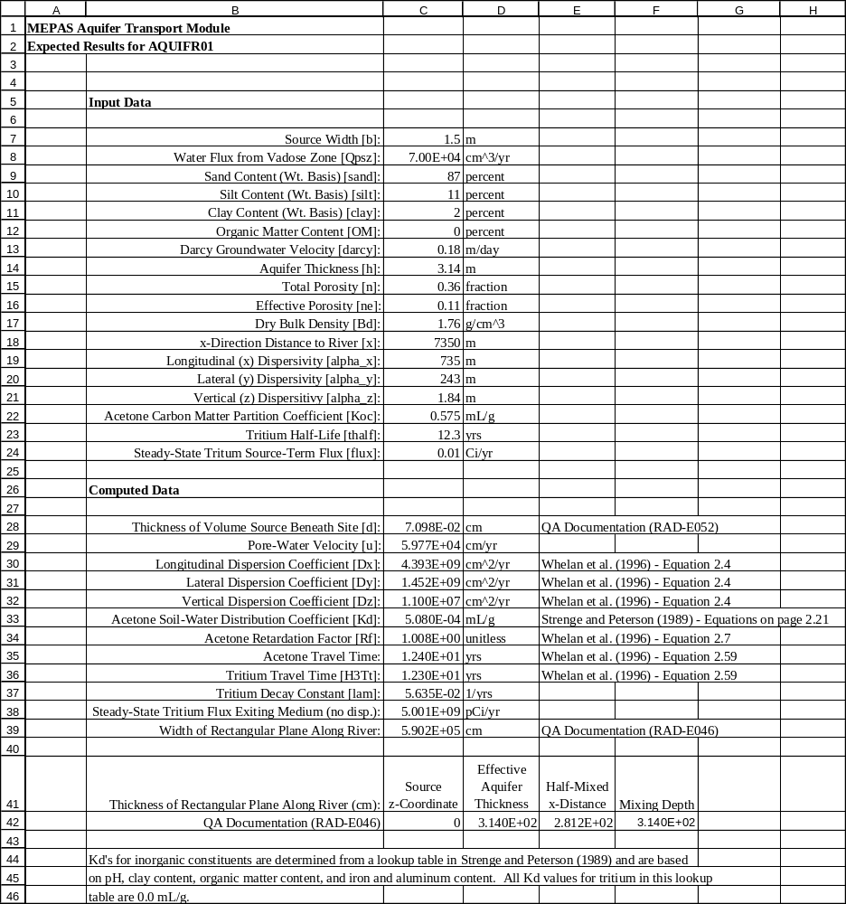
AQUIFR01 Expected Results.xls (formulas)

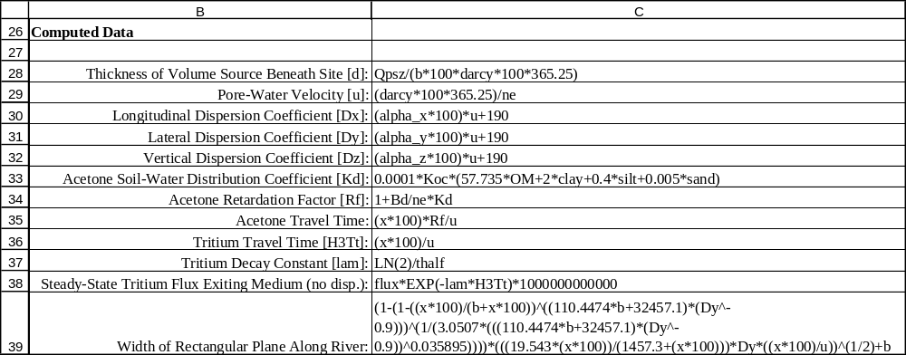
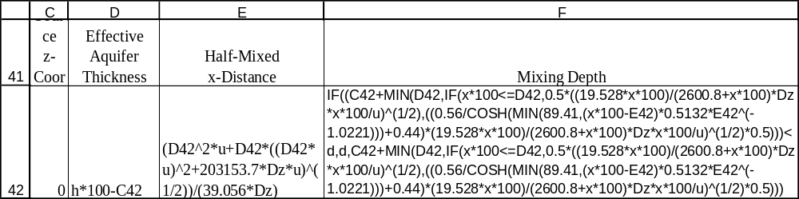

AQUIFR02 Expected Results.xls

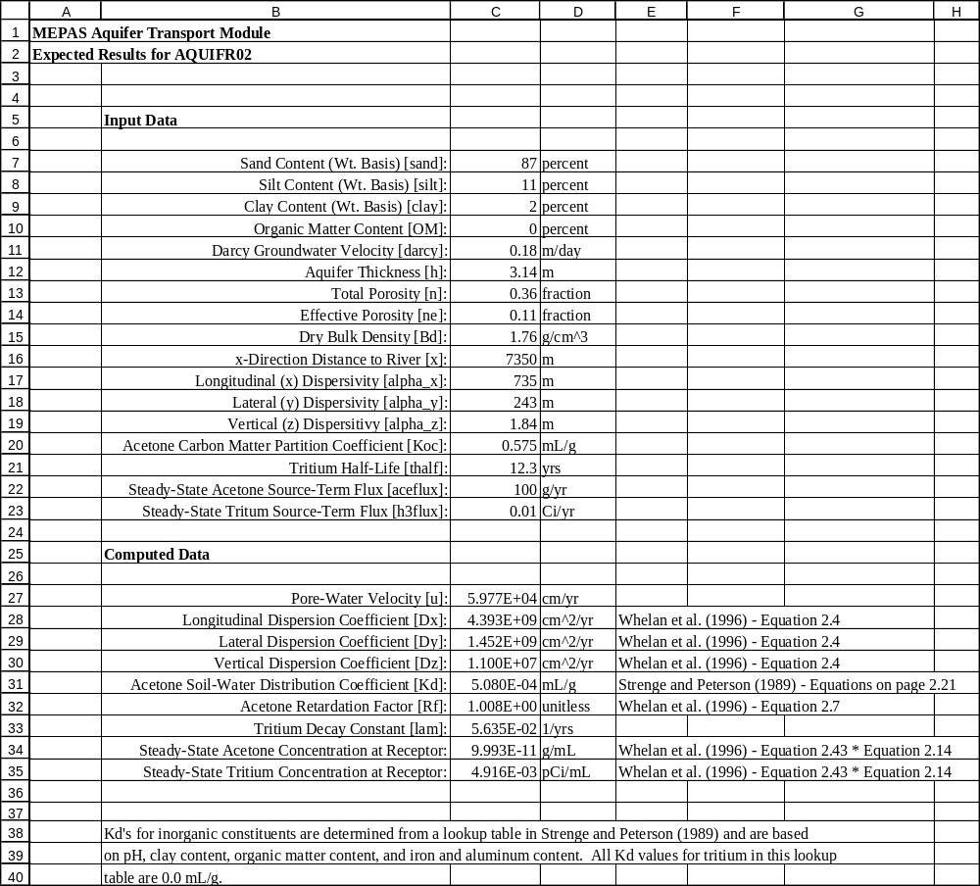
AQUIFR02 Expected Results.xls (formulas)

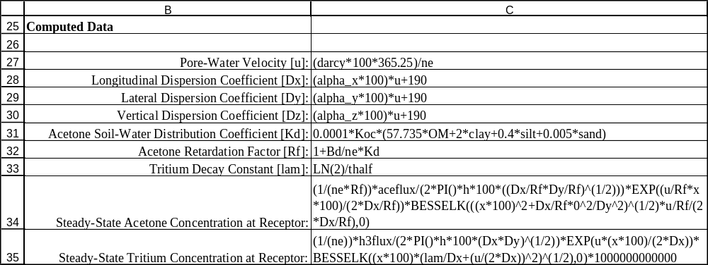
AQUIFR04 Expected Results.xls

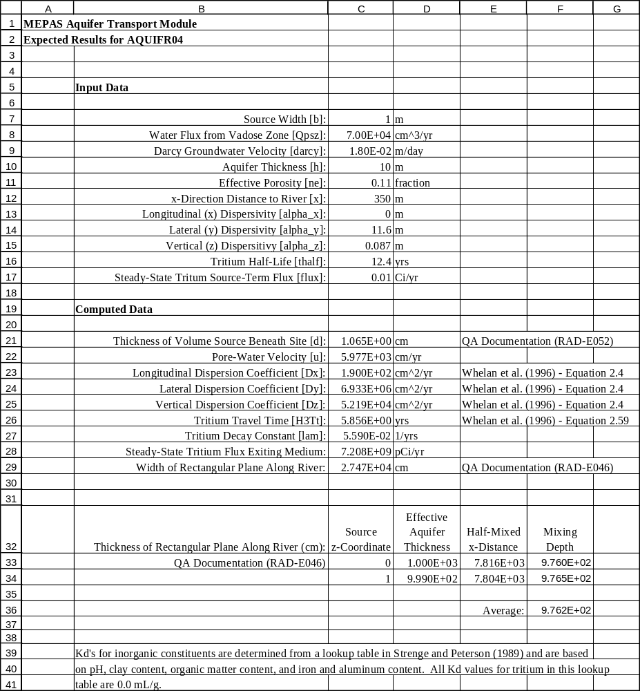
AQUIFR04 Expected Results.xls (formulas)

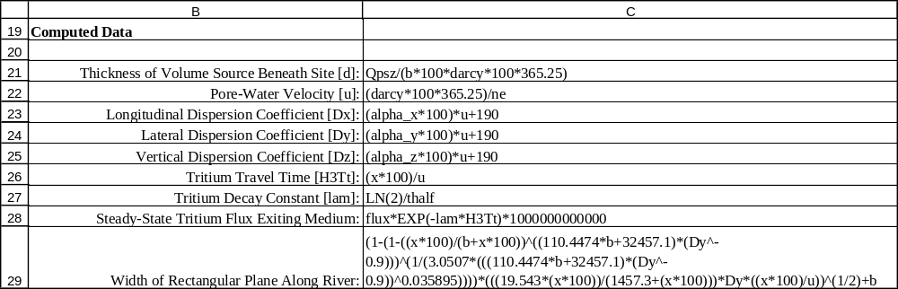
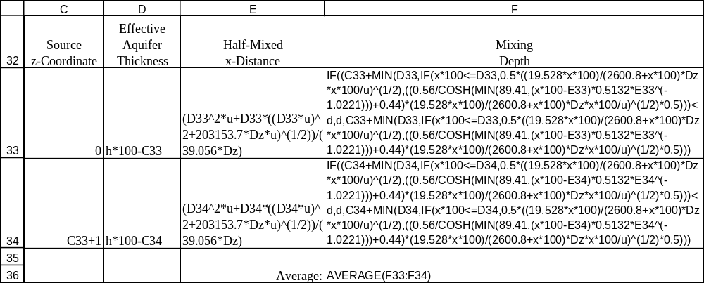

AQUIFR05 Expected Results.xls

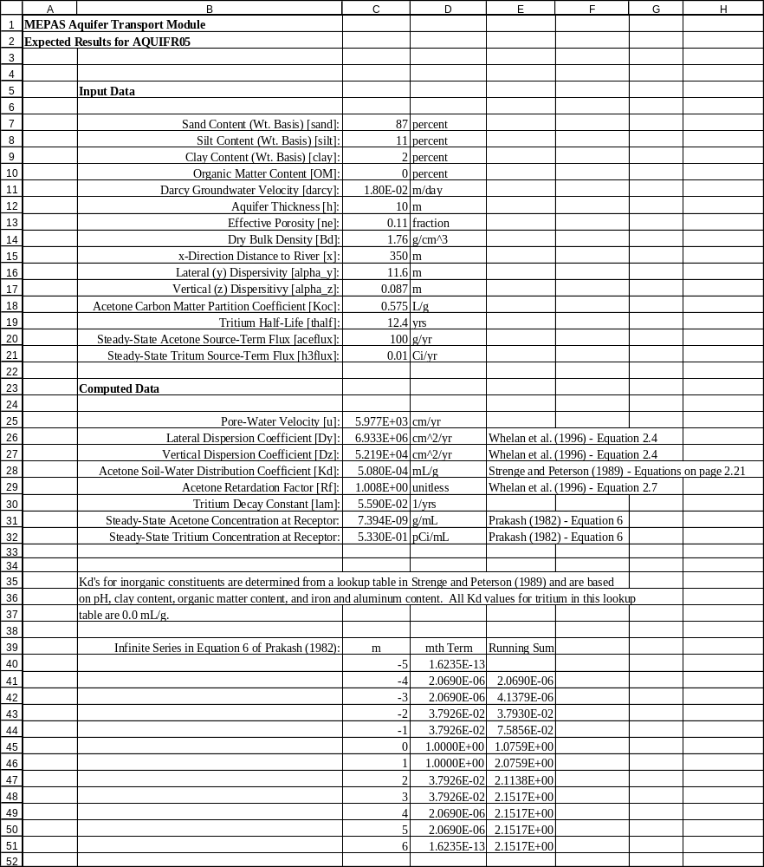

AQUIFR05 Expected Results.xls (formulas)

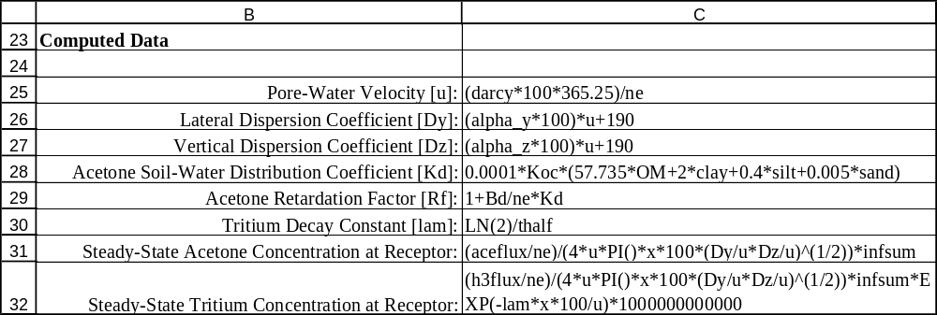
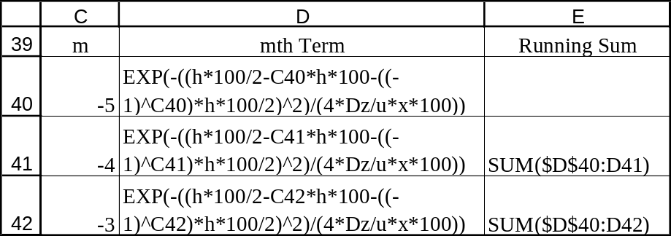

AQUIFR07 Expected Results.xls

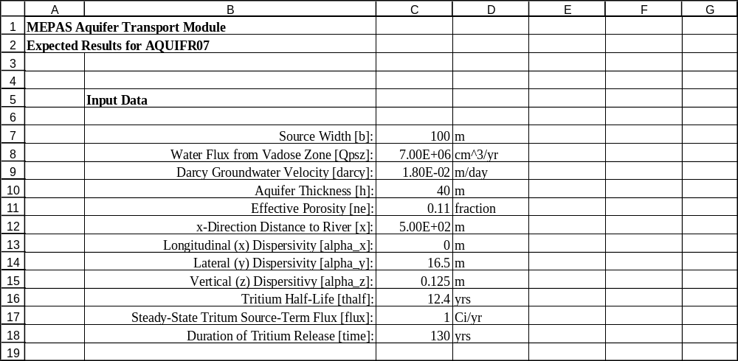
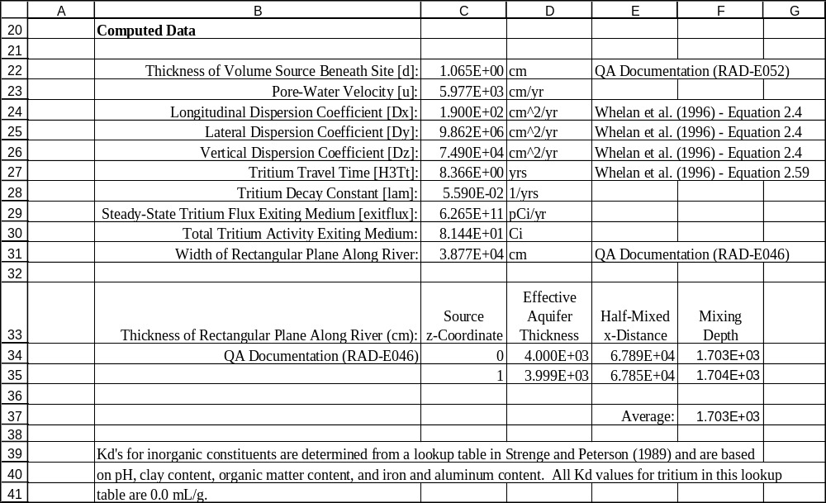
AQUIFR07 Expected Results.xls (formulas)

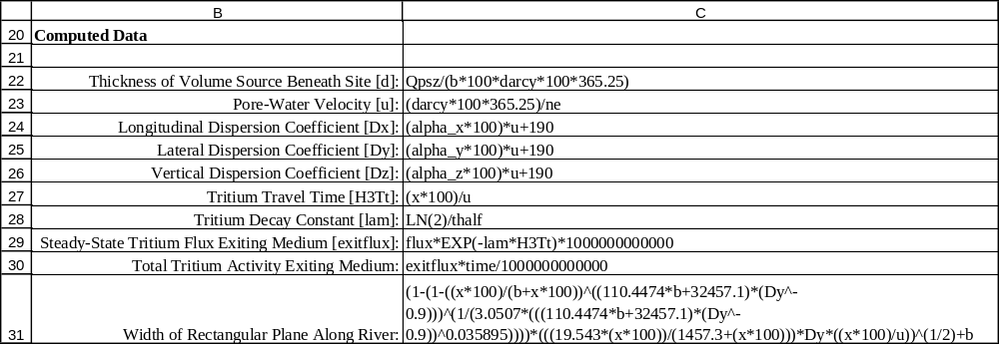

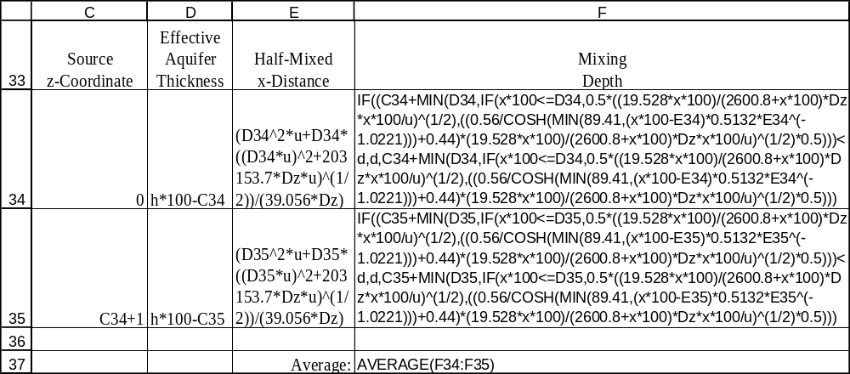

AQUIFR08 Expected Results.xls

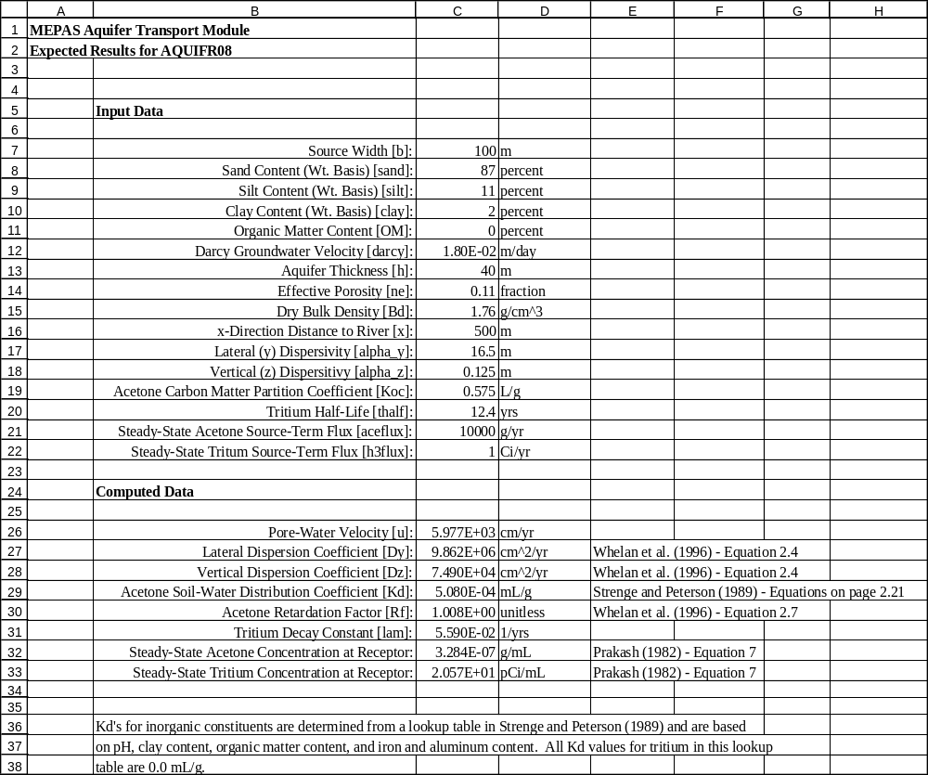

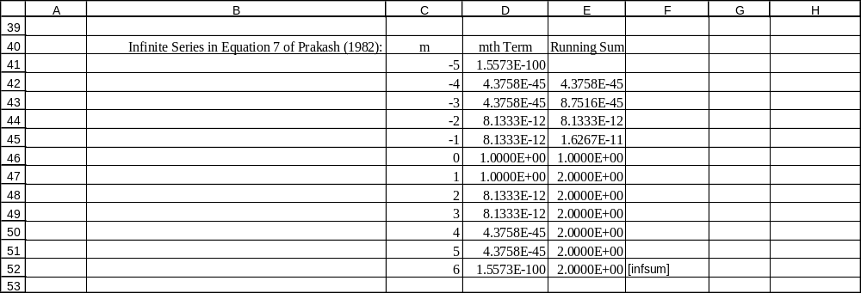
AQUIFR08 Expected Results.xls (formulas)

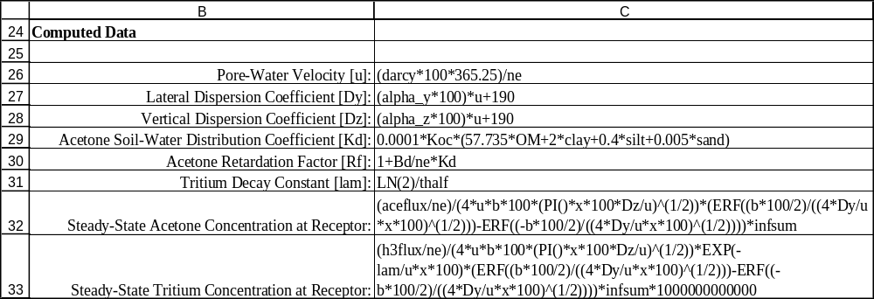
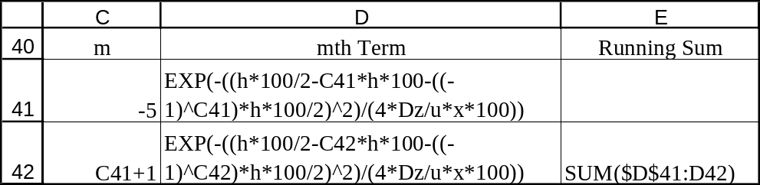
AQUIFR10 Expected Results.xls

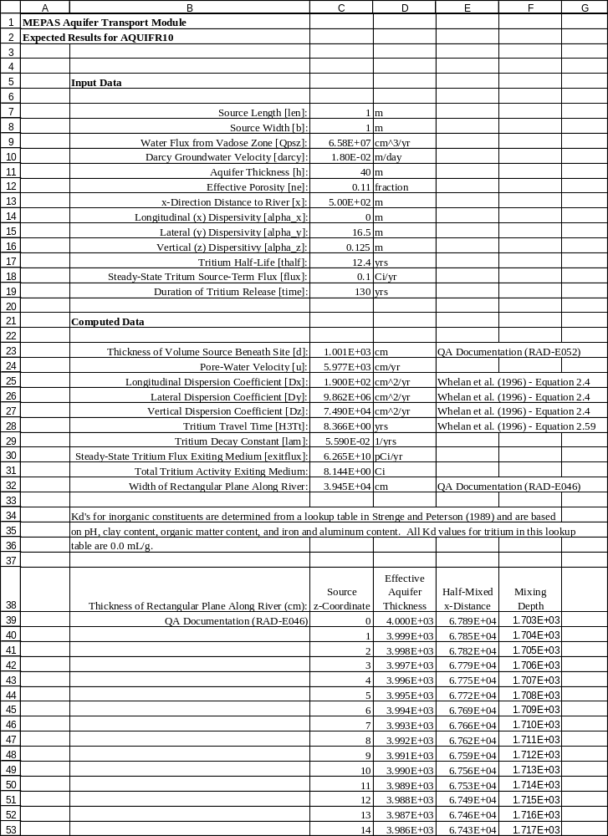
(rows 54 through 986 omitted)

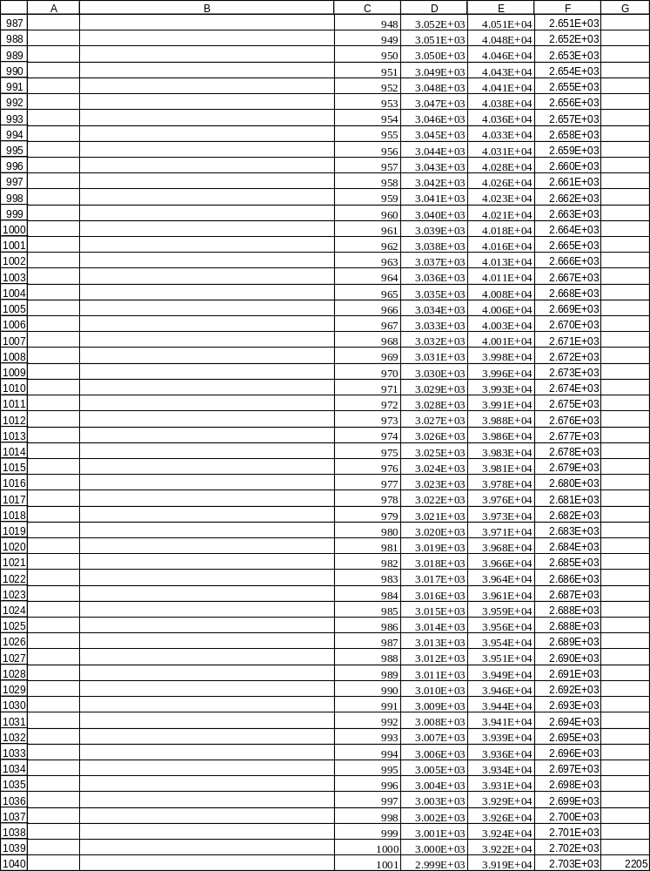

AQUIFR10 Expected Results.xls (formulas)

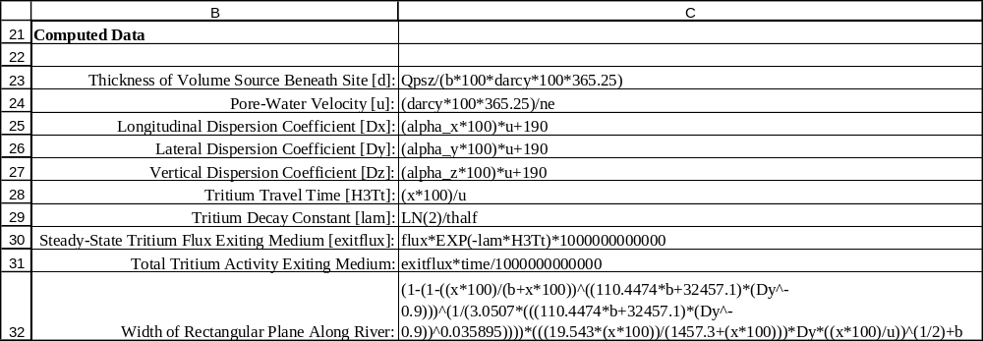
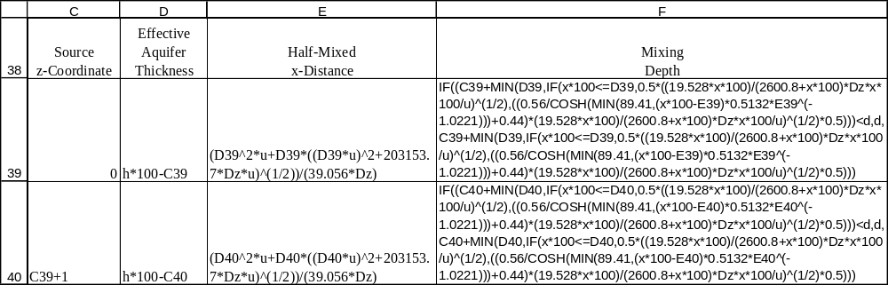

AQUIFR11 Expected Results.xls

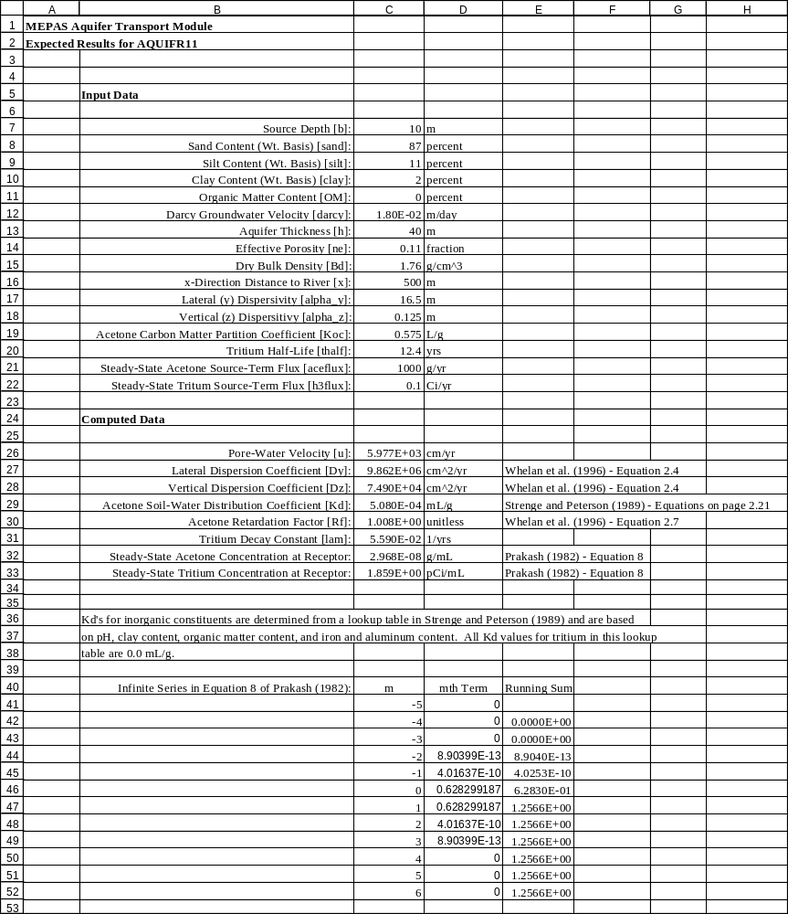

AQUIFR11 Expected Results.xls (formulas)

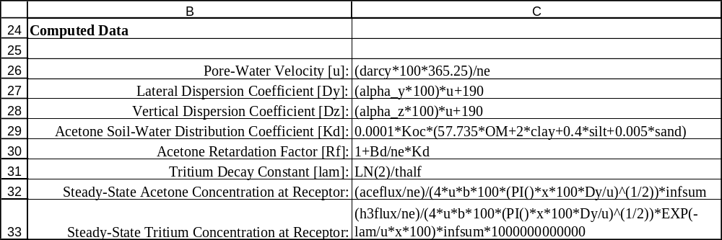
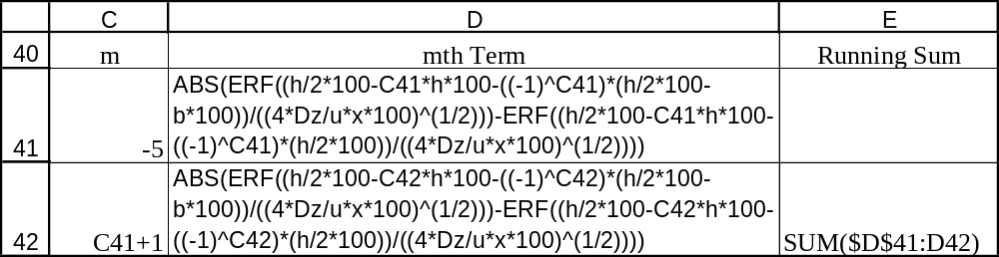

AQUIFR13 Expected Results.xls

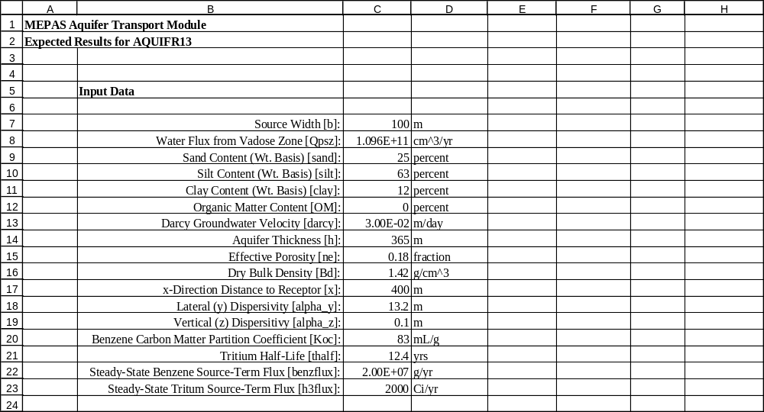
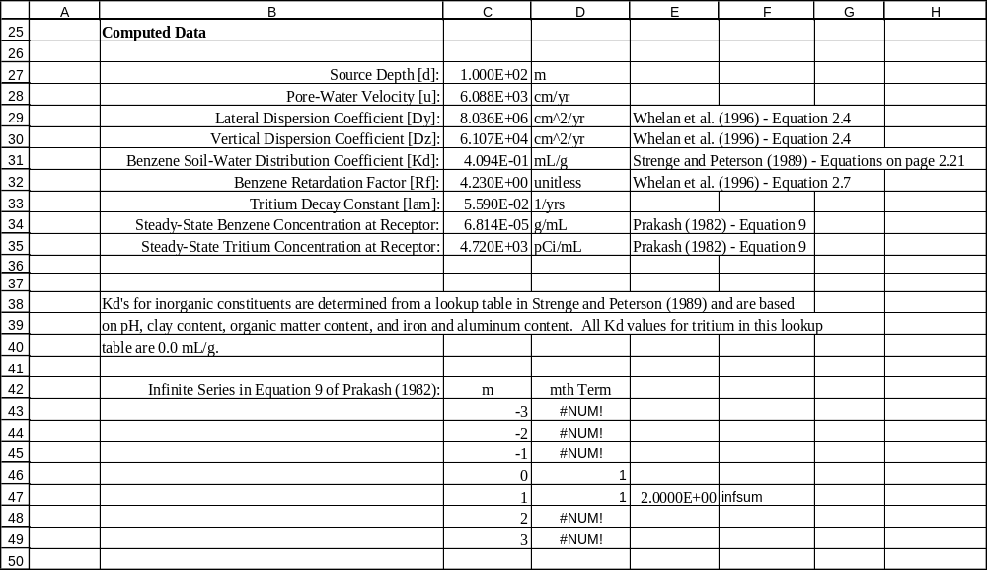
AQUIFR13 Expected Results.xls (formulas)

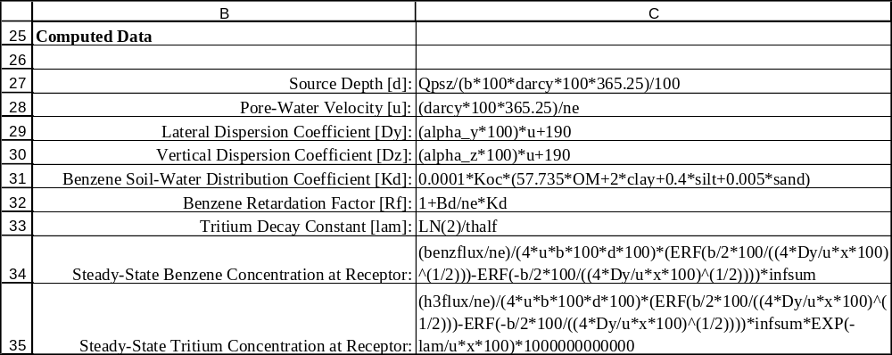
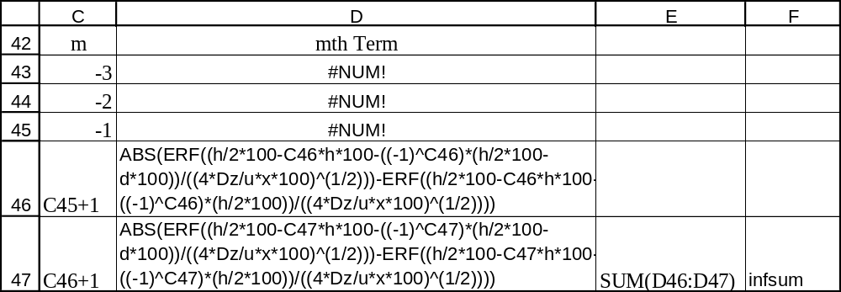
AQUIFR15 Expected Results.xls

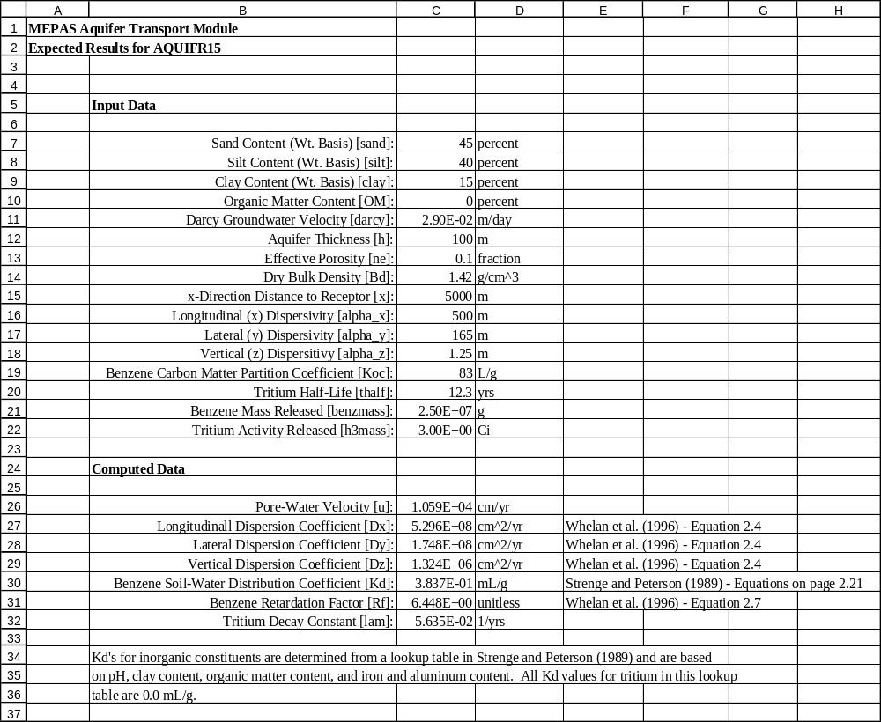
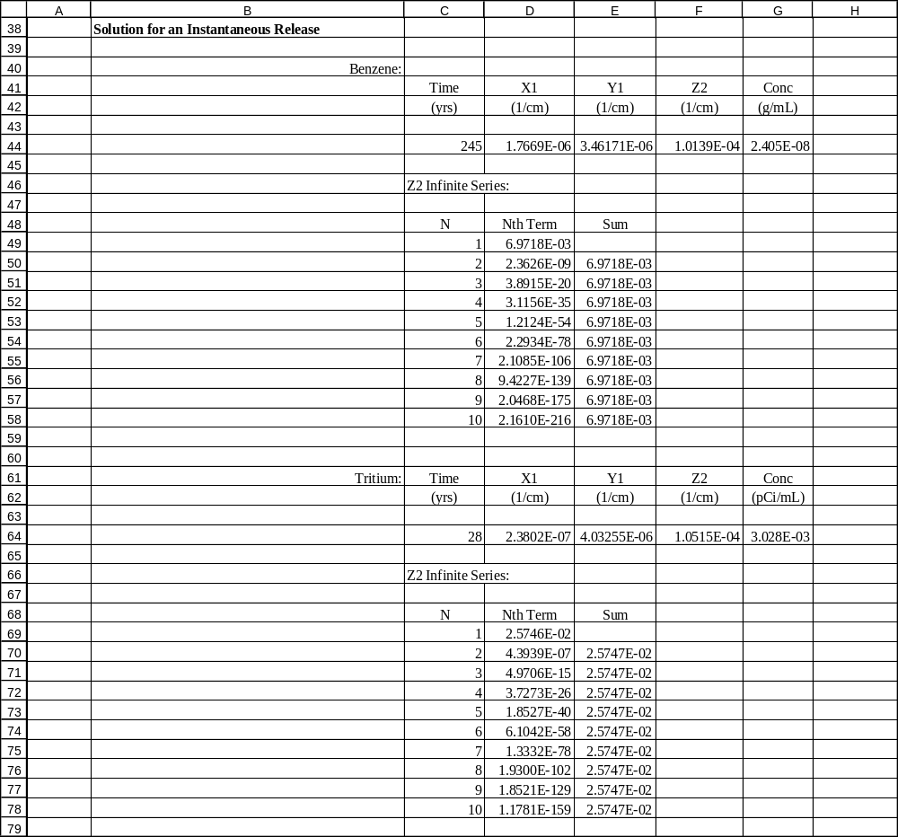
AQUIFR15 Expected Results.xls (formulas)

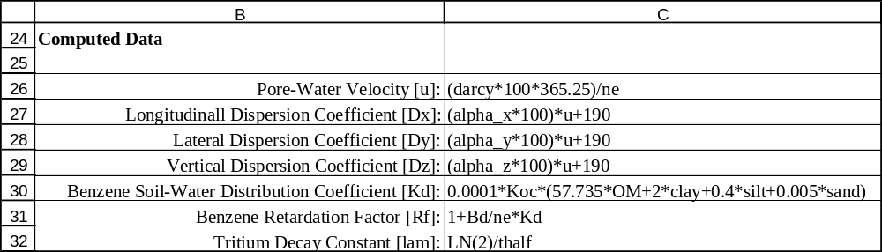
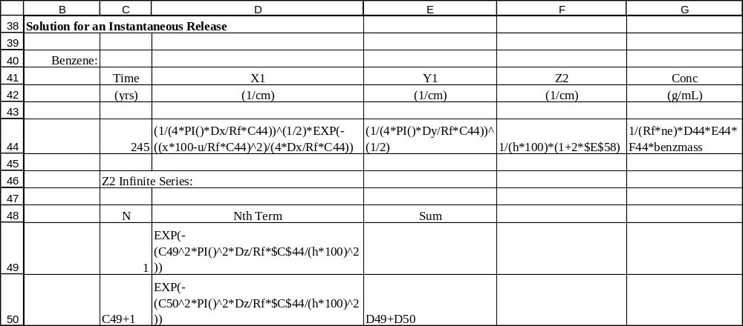
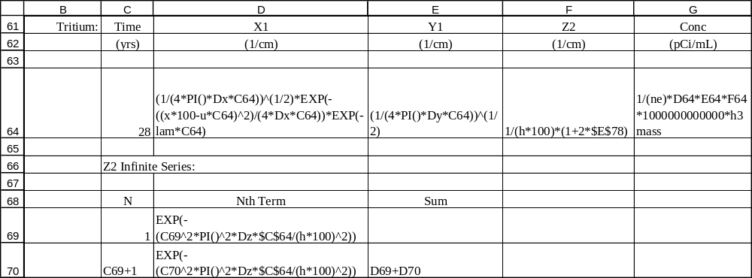

Appendix B
General Procedure for Conducting the Tests

This appendix describes the general procedure for conducting the tests in this plan. After starting FRAMES, select the contaminant icon and drag it to the workspace. Double click on this icon, click ‘OK’, name the *.GID file the same as the name of the test (e.g., aquifr01), and select the contaminants to be used in the test and click ‘OK’. Then, build the rest of the conceptual-model picture by selecting the source icon and dragging it to the workspace, followed by dragging the aquifer icon to the workspace. Using the right mouse button, drag from the source icon to the aquifer icon to add an arrow. If the test case calls for concentrations to be computed, drag an exposure icon to the workspace and connect the aquifer icon to the exposure icon using an arrow. If the test case calls for fluxes to be computed, add a river icon to the workspace, and connect the aquifer icon to the river icon.

To select a specific source model, double click on the source icon, select “MEPAS User-Defined Contaminant Emissions,” and name the icon. The user interface for this module then appears with a “Water Flux” tab only. For test cases where leachate enters the aquifer from the vadose zone, set the contaminanted media to “Vadose’, and enter the source width and length into the “Width of flux plane” and “Length of flux plane” fields, and enter a zero into the “Distance from water table’ field. For test cases where the source is contaminanted groundwater (y-z area source), set the contaminanated media to ‘Aquifer’, and enter the source width and height into the ‘Width of flux plane’ and ‘Height of flux plane’ fields, and enter the depth to the top of the plane below the water table into the “Distance from water table” field. “Natural discharge rate” is not used by the saturated zone module, so just enter zero in this field. The next thing is to enter the infiltration rate (through the source plane) and the contaminant mass fluxes as time series. The water flux series should be from year 0 to year 10,000. The value of the water flux is the infiltration rate times the area of the source for vadose contaminanted media, or the darcy groundwater velocity times the area of the source for aquifer contaminated media (in the case of aquifer contaminated media, this water flux is not used, so an entry of zero would suffice). Use the drop down menu or the side-to-side arrows to select each contaminant and enter the source flux time series as defined in the input data section for the test case. After entering all the data, select “Save and Exit” from the file menu. Then, double click on the source icon to run the source module.

To define the saturated zone, double click on the saturated zone icon, select “MEPAS Saturated Zone,” name the icon, and then click ‘OK’. The user interface for this module then appears. Proceed to enter the physical characteristics of the saturated zone along with the Kd’s for each constituent as directed in the input data section for the test case. When data entry is complete, select “Save and Exit” from the file menu. Double click on the icon to run the module.

Flux output results are contained in the *.WFF file, where the * is the name of the test case. Concentration output results are contained in the *.WCF file. The viewer icon within FRAMES can be used to view these files, or a spreadsheet package can be used to load these files and plot the results. To use the viewer icon, drag it to the workspace, and drag an arrow using the right mouse button from the aquifer icon to the viewer icon (dragging from the viewer icon to the aquifer icon won’t work). To view the WLS and WIN files, use a text editor or word processor. These files reside in the same directory in which FRAMES is installed (usually, c:\fui) and have the names MEPAS_AQ.WLS and MEPAS_AQ.WIN. Each time the aquifer module is executed, these files are overwritten, so they only contain information for the latest run. Rename the files if you wish to save them.

